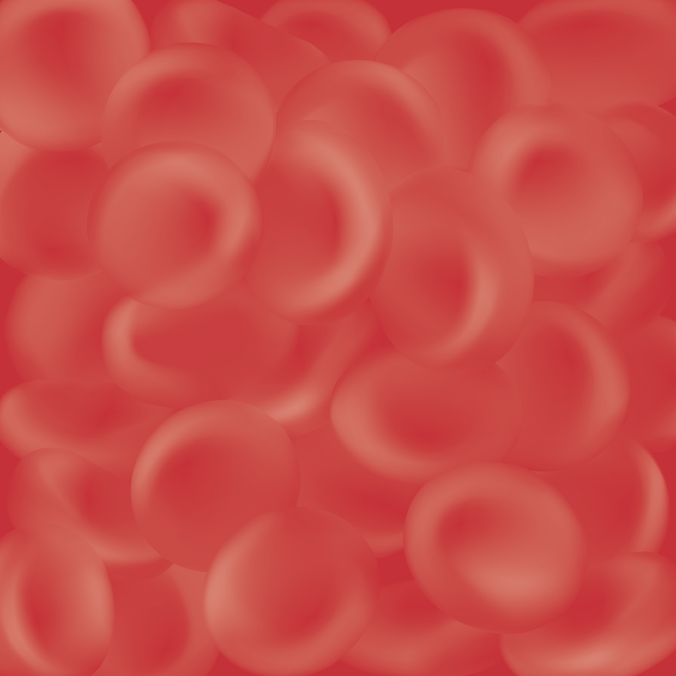
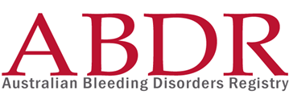
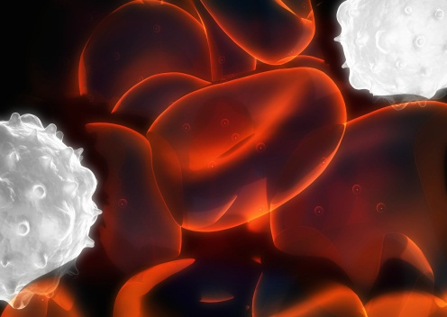
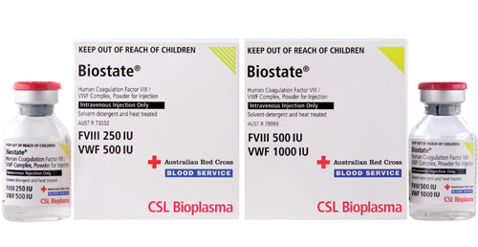
Annual Report
2010-2011


With the exception of any logos and registered trademarks, and where otherwise noted, all material presented in this document is licensed by the NBA under a Creative Commons Attribution 3.0 Australia (http://creativecommons.org/licenses/by/3.0/au/) licence. In essence this licence allows you to copy, communicate and adapt the work, as long as you attribute the work to the National Blood Authority and abide by the other licence terms.
The content obtained from this document or derivative of this work must be attributed as the Australian Bleeding Disorders Registry (ABDR) Annual Report 2010-2011 published by the National Blood Authority.
ISSN 1839-0811
This report is available online at http://www.nba.gov.au/abdr

National Blood Authority
Locked Bag 8430
Canberra ACT 2601
AUSTRALIA
Telephone: +61 2 6211 8300
Facsimile: +61 2 6211 8330
Website: www.nba.gov.au
.

Table of Contents
1. Table of Contents i
1.1. Glossary (main terms) ii
2. Executive summary 2
2.1. Purpose 2
2.2. Key observations 2
3. Background 4
3.1. What are bleeding disorders? 4
3.1.1. Haemophilia 4
3.1.2. von Willebrand disease 4
3.1.3. Severity 4
3.1.4. Treatment of bleeding disorders 5
3.2. Treatment arrangements in Australia 5
3.3. What is the ABDR? 6
3.4. ABDR Management and Governance 7
3.4.1. Accessing the data 7
3.5. Data quality issues 7
4. Patients in the Registry 10
4.1. By diagnosis 10
4.2. By geography 18
4.3. Incidence of major disorders 19
4.4. By age distribution 22
4.5. By Inhibitors 23
5. Patients who received treatment 26
5.1. By severity 26
5.2. National average issues of Factor VIII by severity 28
5.3. By weight and height 30
5.4. By age distribution 31
6. Volume and cost of products used in the treatment of bleeding disorders 34
6.1. National issues by product 34
6.2. Reported use of Factor IX by HmB patients selected countries 36
6.3. National Costs for products issued 37
7. Appendices 40
Appendix A Haemophilia Treatment Centres 40
1. The objectives of HTCs 40
2. Operating concept 40
3. Data Quality of HTC data collections 42
Appendix B History and development of the ABDR 44
4. Benefits of the redeveloped ABDR 44
5. Current position of the development of the ABDR 44
Appendix C ABDR data collection (registration form) 45
7.1. List of Figures 47
7.2. List of tables 48

Glossary (main terms)
Abbreviation | Meaning
NBA | National Blood Authority
HTC | Haemophilia Treatment Centre
AHCDO | Australian Haemophilia Centres Directors’ Organisation
HFA | Haemophilia Foundation Australia
ABDR | Australian Bleeding Disorders’ Registry
IDMS | Integrated data management system – The NBA’s integrated data management system.
PWBD | People with a bleeding disorder
HmA | Haemophilia A (Factor VIII deficiency)
HmB | Haemophilia B (Factor IX deficiency)
vWD | von Willebrand disease
DDAVP | Desmopressin (1-desamino-8-D-arginine vasopressin, abbreviated DDAVP) a derivative of the antidiuretic hormone, used to treat patients with von Willebrand disease. It does not come under the national blood agreement funding arrangements and its use is often not recorded in the NBA’s issues database.

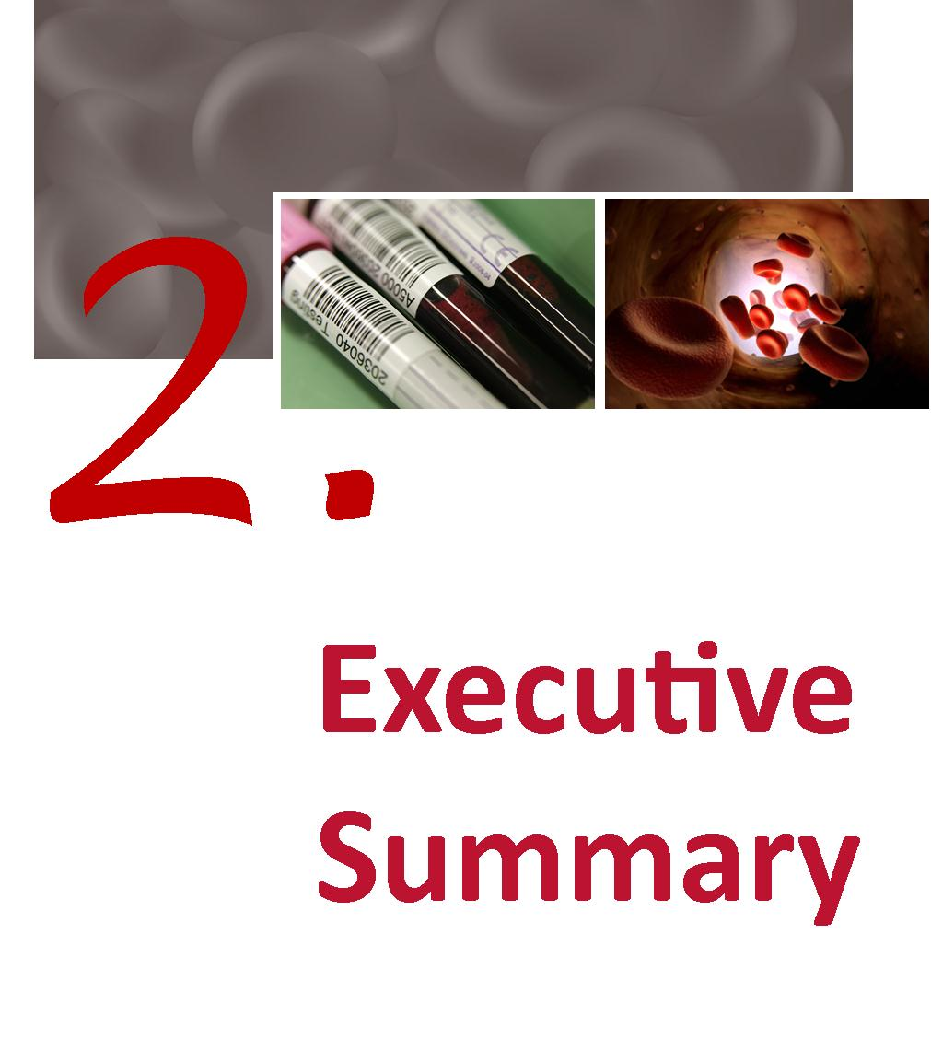

Executive summary

Purpose
The purpose of this report is to provide an integrated view of current clinical and demographic information on people with bleeding disorders in Australia and the resultant demand for clotting factor products. It draws on data from the Australian Bleeding Disorders Registry (ABDR) and other National Blood Authority (NBA) supply and contract sources. Some international data comparisons have also, where meaningful, been included.

The 2010-11 report represents the second analysis of the ABDR data since a redevelopment in 2008. This analysis builds on feedback from clinicians and other stakeholders following publication of the first report. It also provided impetus to continue data quality improvements.
This report has been developed through the close collaboration of all stakeholders involved in the management and governance of the ABDR, namely:
- Australian Haemophilia Centre Directors’ Organisation (AHCDO)
- Haemophilia Foundation of Australia (HFA)
- National Blood Authority (NBA).

Key observations
The data contained in the report shows:
- between 2009-10 and 2010-11, there was an increase of 283 patients registered in the ABDR, bringing the total number to 5260
- the overall growth in numbers of people with bleeding disorders captured in the Registry was 5.7 per cent; the major contributions to this were growth in numbers captured of people with von Willebrand Disease (vWD) 2.2 per cent, Haemophilia A (HmA) + Haemophilia (HmB) 2.5 per cent and other disorders 1.0 per cent
- the number of patients with a severity ranking of ‘severe’ increased by 25 (haemophilia patients only). This brings haemophilia patients with a ‘severe’ ranking to 14 per cent of the total number of all people in the registry;
- there was no significant change in the proportion of people in the registry treated between reports
- there was a large percentage increase in the number of people in the registry with Factor XI deficiency (13.5 per cent) and for platelet disorders (12.4 per cent), the total number of these patients is, however, very small
- there was an 8 per cent increase in the number of females recorded in the registry.
A proportion of these increases seen reflects retrospective data entry of existing patients that were not previously recorded in the national system. Further, these results are tempered by some data quality issues. These data were cleansed to allocate to the correct product use where other data were available. In some areas inconsistent definitions appear to be used for some fields.
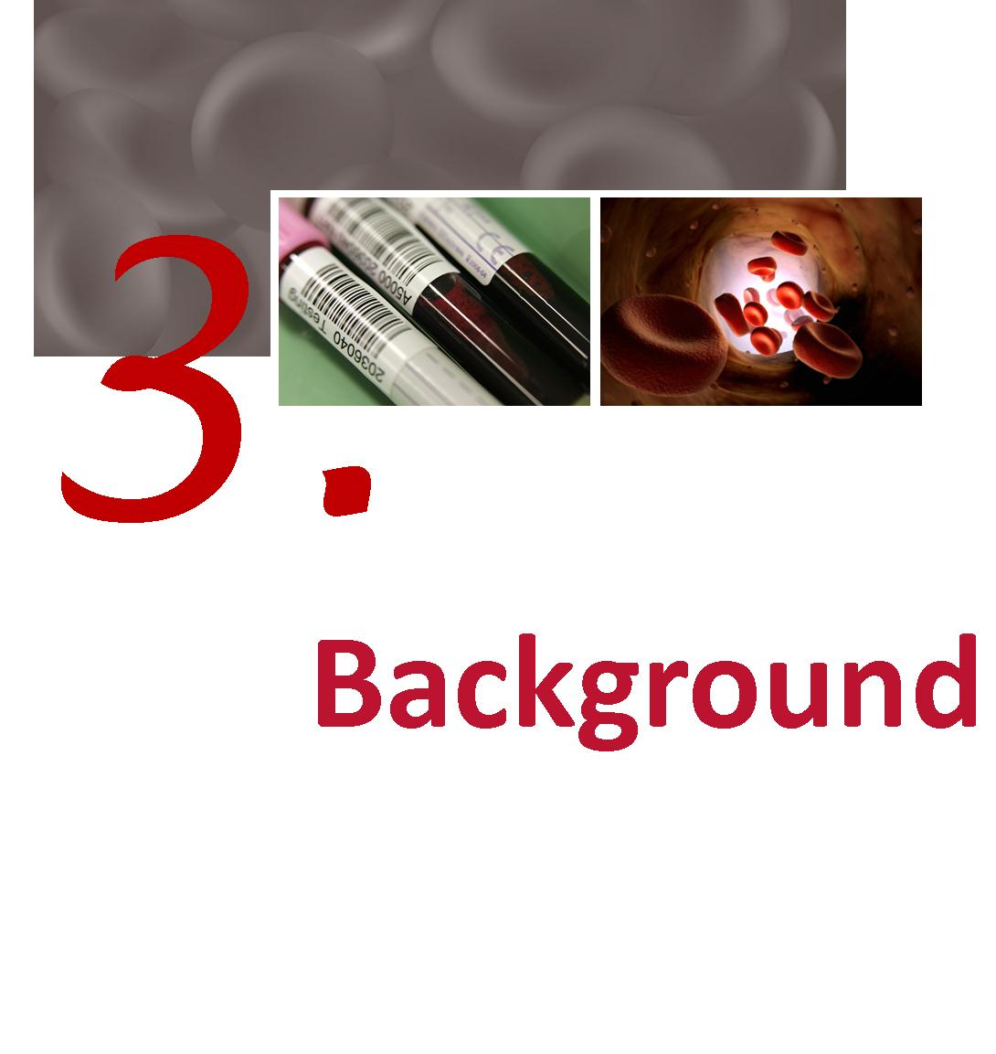

Background

What are bleeding disorders?

Haemophilia
Haemophilia occurs in 1 in 6,000-10,000 males internationally.
In Australia, there are approximately 2,600 people with varied degrees of severity of this condition. There are 2 types of Haemophilia:
- Haemophilia A (classical Haemophilia) is the most common type and caused by a deficiency of blood clotting factor VIII
- Haemophilia B (Christmas Disease) is due to a deficiency of blood clotting factor IX.
Haemophilia is an inherited condition and occurs in families. In one-third of cases, however, it appears in families with no previous history of the disorder. Haemophilia is due to a mutation in the Factor VIII or Factor IX gene which is on the X chromosome. The haemophilia gene is passed down from mother to child through generations. Some women and girls who carry the haemophilia gene may also experience bleeding problems.
The deficiency in clotting factor is associated with recurrent bleeding episodes, usually into the joints, muscles or internally, possibly affecting vital organs. These bleeding episodes, or “bleeds”, may occur spontaneously, or as a result of trauma or injury. The bleeding is arrested by infusion of the appropriate clotting factor. Over a period of time recurring bleeding into joints and muscles can cause serious sequelae, including arthropathy, and chronic pain syndromes.
With appropriate treatment haemophilia can be managed effectively.

von Willebrand disease
vWD is a related bleeding disorder which affects both men and women. This disorder is more common and is caused by a deficiency and/or dysfunction of von Willebrand factor.
Table 1 Major bleeding disorders and their cause
Disorder group | Cause
Haemophilia A | Deficiency in factor VIII
Haemophilia B | Deficiency in factor IX
von Willebrand Disease | Deficiency, or dysfunction, in von Willebrand factor
Other factor deficiencies | Deficiency in other coagulation factors
Platelet Disorder | Inherited deficiency in effective platelet function

Severity
Haemophilia A and B are classified according to their severity, as this informs the treatment regimens required. The definitions of severity that are applied within the ABDR are listed in Table 2. Definition of severity of vWD and other coagulation factor deficiencies is variable.
Table 2 Severity and the concentration of clotting factors
Severity | Concentration of  Clotting Factor | Typical Bleeding Picture
Severe | <0.01 IU/ml  (<1% of normal†) | Frequent bleeding episodes common, predominantly into joints & muscles. Bleeding can occur spontaneously or after minor injury.
Moderate | 0.01 – 0.05 IU/ml  (1–5% of normal) | Can bleed after minor injury. May have joint bleeding. Severe bleeding with trauma, surgery, invasive procedures.
Mild | >0.05 – 0.40 IU/ml  (5-40% of normal)‡ | Spontaneous bleeding does not occur. Bleeding with major trauma, surgery, invasive procedures.
Notes † Normal concentration of factor VIII or IX is defined as 100% or one unit of factor VIII activity per ml of plasma - 100 U/dL (Kasper, CK 2004, Hereditary plasma clotting factor disorders and their management. Treatment of Hemophilia Monograph Series, No. 4, World Federation of Hemophilia, Montreal, Canada.).
‡ levels of FVIII above 40% are usually considered sufficient for normal haemostasis.

Treatment of bleeding disorders
Mild conditions may require no treatment or treatment only under special circumstances, such as surgery. More severe conditions may require regular interventions. Treatment may occur in hospital or other medical facilities, or at home. The treatments may be regular and preventative (prophylaxis), or on demand (when a bleed occurs).
Often the treatments involve providing replacement for the missing or defective clotting factors. Products used include plasma derived and recombinant clotting factors, cryoprecipitate and Desmopressin (1-desamino-8-D-arginine vasopressin, abbreviated as DDAVP). In some patients, therapy is complicated when their body develops inhibitors that destroy the replacement clotting factors and other treatment is necessary.

Treatment arrangements in Australia
The majority of people with these conditions are treated at Haemophilia Treatment Centres (HTCs) which are specialist centres that provide comprehensive care to people with haemophilia and other coagulation deficiencies. The comprehensive care model ensures that preventative and general treatment on the complex aspects of haemophilia are given in a co-ordinated way by a multi-disciplinary team within the one centre.
HTCs were established under a decision by Australian Health Ministers Advisory Council (AHMAC) in February 2001, to provide a leadership role within their hospital, city and outlying areas to ensure optimal care and an equitable distribution of professional and therapeutic resources, together with responsible record-keeping. Specific roles of these Centres are defined in Appendix A. The locations of the HTCs in Australia are shown in Figure 1.
The manner in which these functions are delivered varies between jurisdictions including the degree to which they:
- operate within centralised compared to distributed treatment models;
- focus on treating paediatric or adult patients compared to treating all age groups; and
- have relatively small numbers of patients compared to relatively large numbers – commonly based on geography.

Nevertheless, there are some patients that receive product from clinicians not associated with a HTC. The proportion of product that is used in these circumstances varies across jurisdictions and there is some variability in the data capture rate within jurisdictions. Accordingly, data on total volume of products recorded from the ABDR may not be consistent with data provided by the NBA from other sources.
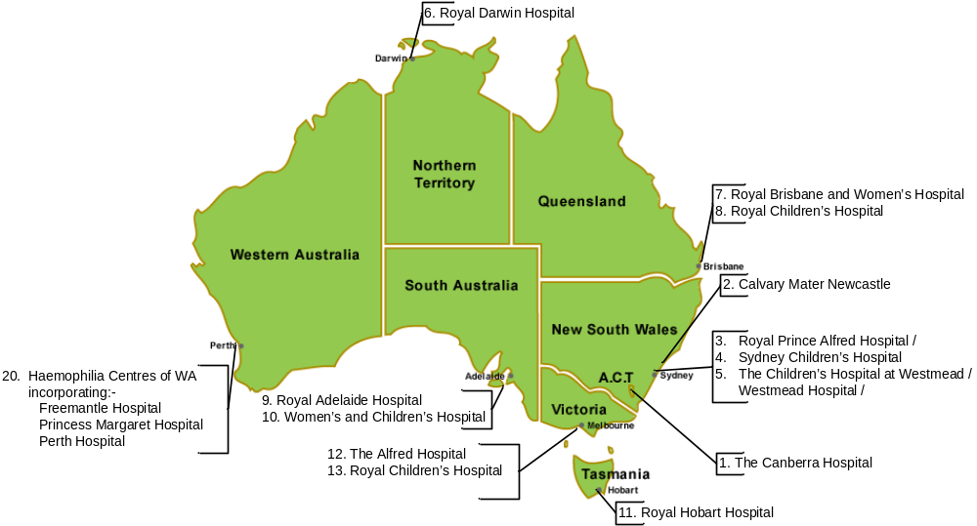
Figure 1 Location of HTCs
A description of the aims and governance of HTCs is provided at Appendix A.

What is the ABDR?
The Australian Bleeding Disorders Registry (ABDR) is a database that is designed to collect all clinical information related to the treatment of people with bleeding disorders. This includes information about patient diagnosis, including viral status, treatment details, hospital admissions and administrative information as well as details on ordering, supply and use of clotting factor products. Information is entered into the ABDR web enabled software by staff at HTCs. The current version of the ABDR has been in existence since December 2008 and background on the development of the system is at Appendix A.

ABDR Management and Governance
The ABDR is managed on a day to day basis by the NBA in accordance with the guidance and policy oversight provided by the ABDR Steering Committee. The Committee consists of representatives of the key stakeholders involved in the clinical management, advocacy and funding of treatment for people with bleeding disorders. In 2010/11 the Steering Committee representatives were:
- Dr John Rowell – Chair – representative of Australian Haemophilia Centre Directors’ Organisation (AHCDO)
- Dr Chris Barnes – Chair of Australian Haemophilia Centre Directors’ Organisation (AHCDO)
- Ms Sharon Caris – Executive Director, The Haemophilia Foundation Australia (HFA)
- Mr Geoff Simon, Queensland Health – Jurisdictional Blood Committee nominee
- Ms Stephanie Gunn – Acting General Manager, National Blood Authority

Accessing the data
Patient confidentiality is paramount, with personal data available only to the individual treating HTC and levels of authorisation/access determined by the interaction of staff with individual patients. National reporting is with aggregate, de-identified, data. All use of data, and discussion about the system, other than within the individual HTC, is considered by the ABDR Steering Committee.
The database provides a capability for all HTC staff to enter data on the interactions with patients to provide treating clinicians with a comprehensive picture of the health and wellbeing of patients. The database provides for both real time ordering of product and retrospective collection of data to provide national clotting factor usage data to inform and assist planning and funding. Future development of the system will provide for inclusion of information on physiotherapy and social work interactions with patients.
To ensure appropriate management of the information, the NBA has instigated a detailed governance framework for a data analyst to use a Business Intelligence tool to store and access the de-identified data. This tool is called Big Red. It includes data marts for the Integrated Data Management System (IDMS – which records products issued by suppliers) and the ABDR. Big Red can provide fixed reports and ad hoc queries.

Data quality issues
There are a number of data quality issues in the ABDR. These include incomplete records with missing fields or “not stated” entries. As the system is still relatively young, the data in some fields is also characterised by a lack of consistency in the interpretation of specific fields. These caveats are highlighted on specific tables. The Steering Committee has initiated strategies to improve the data quality and over time the reporting from the ABDR will become more robust.
For this report the NBA has expended more effort on cleaning the data and filling in gaps, particularly in relation to cases where clotting factor from hospital stocks was used. The clotting factor use corrections applied to 2009-10 and 2001-11.
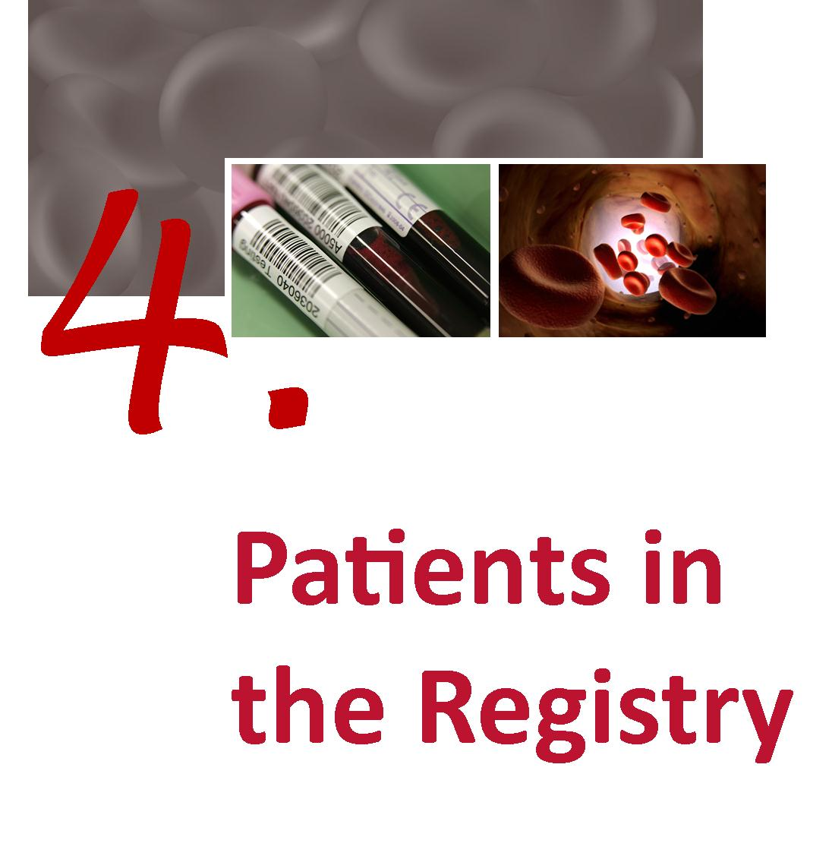

Patients in the Registry
This section of the report presents the key patient data collected by the ABDR. The determination of when a patient is in the register is based on their record creation date. Where another data field implied an earlier creation date the earlier date was used.

Box 1: Data Comparisons Note
The data extract used in this year’s report reflects the current state of the data. If a patient was diagnosed in 2009-10 but was only added to the registry during 2010-11 they will now be included in the count of people in the registry at 30 June 2010. This explains difference to the previously reported numbers for 30 June 2010.
The largest contributions to the revisions to the “in registry on 30 June 2009” are in vWD (38 per cent of total revisions). Others are: 37 per cent; HmA 29 per cent; and unknown 27 per cent. These seem to indicate that there is now better coverage of vWD patients in the Registry. The unknown diagnoses have been better allocated to a meaningful diagnosis.
These changes, while complicating the ability to undertake trend analysis at this stage, do reflect an improved data capture rate for the Registry and this scale of adjustment to previous years data is not expected to occur in future years.
In summary – where the data for 2010-11 is compared with the numbers published in the 2009-10 report, growth is likely to reflect improvements to the data rather than simply changing patterns in numbers of patients with particular diagnoses.

By diagnosis
Table 3 Number of people in the register and treated by latest broad diagnosis
 | Number in register at 30 Jun 2009 | Number who Received product in 2008-09 | Number in register at 30 Jun 2010 | Number who Received product in 2009-10 | Number in register at 30 Jun 2011 | Number who Received product in 2010-11
HmA† | 1918 | 693 | 2015 | 833 | 2111 | 858
HmB† | 466 | 153 | 490 | 186 | 517 | 185
vWD | 1714 | 101 | 1856 | 183 | 1966 | 153
Other Factor Deficiency | 235 | 21 | 261 | 18 | 284 | 22
Platelet Disorder | 161 | 1 | 170 | 4 | 191 | 8
Vascular | 5 | 0 | 5 | 0 | 6 | 0
Other | 138 | 2 | 143 | 0 | 146 | 2
Unknown | 35 | 0 | 37 | 0 | 39 | 0
Total | 4672 | 971 | 4977 | 1224 | 5260 | 1228
Note: † Includes some female carriers who are symptomatic.
As noted in Box 1 the historical data has been revised from the 2009-10 report reflecting changes in data capture rates between years.
Table 4 Number of people in the register and treated by detailed diagnosis HmA, HmB & vWD
Detailed diagnosis | Number in register at 30 Jun 2009 | Number who Received product in 2008-09 | Number in register at 30 Jun 2010 | Number who Received product in 2009-10 | Number in register at 30 Jun 2011 | Number who Received product in 2010-11
Factor VIII Deficiency (Haemophilia A) | 1670 | 680 | 1745 | 812 | 1814 | 843
Asymptomatic Carrier Factor VIII Deficiency (Haemophilia A) † | 224 | 7 | 238 | 12 | 261 | 8
Acquired Factor VIII Inhibitor (Acquired Haemophilia A) | 24 | 6 | 32 | 9 | 36 | 7
Factor IX Deficiency (Haemophilia B) | 412 | 152 | 430 | 178 | 446 | 181
Asymptomatic Carrier Factor IX Deficiency (Haemophilia B) † | 54 | 1 | 60 | 8 | 71 | 4
von Willebrand Disease - Uncharacterised | 476 | 7 | 500 | 17 | 519 | 13
von Willebrand Disease Type 1 | 914 | 33 | 1005 | 79 | 1076 | 65
von Willebrand Disease Type 2 - Uncharacterised | 101 | 9 | 111 | 20 | 118 | 16
von Willebrand Disease Type 2A | 59 | 10 | 61 | 15 | 65 | 13
von Willebrand Disease Type 2B | 41 | 6 | 44 | 11 | 43 | 8
von Willebrand Disease Type 2M | 56 | 12 | 66 | 11 | 73 | 10
von Willebrand Disease Type 2N | 18 | 2 | 19 | 2 | 21 | 3
von Willebrand Disease Type 3 | 42 | 18 | 43 | 24 | 43 | 25
Acquired von Willebrand Factor Disease | 7 | 4 | 7 | 4 | 8 | 0
Total | 4098 | 947 | 4361 | 1202 | 4594 | 1196
Notes: † The practice of applying definitions does at this stage vary between HTCs and future work will focus on ensuring consistent approaches are used.
It is rare for asymptomatic carriers to require product. They do not get spontaneous haemorrhages, but some may need product support in times of major trauma, surgery or at parturition.
‡ Not all with von Willebrand disease are treated through HTCs and these figures therefore do not represent the total number of vWD patients in Australia. Note also that the specific classification of vWD is incomplete in the ABDR at this stage.
As noted in Box 1 the historical data has been revised from the 2009-10 report to give a more accurate indication of trends.
Table 5 Number of people in the registry and treated by diagnosis of “other disorders”
Detailed diagnosis | Number in registry at 30 Jun 2009 | Number who received product in 2008-09 | Number in registry at 30 Jun 2010 | Number who received product in 2009-10 | Number in registry at 30 Jun 2011 | Number who received product in 2010-11
Factor V Deficiency | 11 | 2 | 13 | 1 | 13 | 1
Factor VII Deficiency | 51 | 6 | 52 | 6 | 53 | 6
Factor X Deficiency | 11 | 2 | 12 | 1 | 12 | 1
Factor XI Deficiency | 115 | 3 | 133 | 3 | 151 | 5
Factor XII Deficiency | 16 | 0 | 17 | 0 | 17 | 0
Factor XIII Deficiency | 16 | 6 | 16 | 7 | 17 | 7
Fibrinogen – Afibrinogenaemia | 6 | 2 | 7 | 0 | 9 | 1
Fibrinogen – Dysfibrinogenaemia | 7 | 0 | 8 | 0 | 9 | 1
Fibrinogen - Hypofibrinogenaemia | 2 | 0 | 2 | 0 | 2 | 0
Fibrinogen Dysfunction – Uncharacterised | 0 | 0 | 1 | 0 | 1 | 0
Vascular disorders - Ehlers Danlos Syndrome | 5 | 0 | 5 | 0 | 6 | 0
Other (Please specify) † | 138 | 2 | 143 | 0 | 146 | 2
Unknown | 35 | 0 | 37 | 0 | 39 | 0
Total | 413 | 23 | 446 | 18 | 475 | 24
Note: † This represents incomplete data which will be addressed for the next year’s report.
Those with fibrinogen disorders may have been treated with the only funded source of fibrinogen – cryoprecipitate which is not routinely collected within the ABDR.
As noted in Box 1 the historical data has been revised from the 2009-10 report to give a more accurate indication of trends.
Table 4 and Table 5 indicate that the growth in numbers of people registered in the ABDR is consistent with the historical proportion of this group of patients to the overall Australian population. This proportion and the growth is largely consistent with that illustrated in the United Kingdom Haemophilia Centre Doctors' Organisation (UKHCDO) annual report. Both show a growth in the year of about 5 per cent. It is expected that with further improvements in data quality, these comparisons will be made with greater confidence.

Table 6 Number in registry and receiving product by diagnosis of “Platelet disorders”
Detailed diagnosis | Number in registry at 30 Jun 2009 | Number who received product in 2008-09 | Number in registry at 30 Jun 2010 | Number who received product in 2009-10 | Number in registry at 30 Jun 2011 | Number who received product in 2010-11
Platelet - Bernard-Soulier | 1 | 0 | 1 | 0 | 1 | 0
Platelet - Glanzmann's Thrombasthenia | 6 | 0 | 7 | 2 | 10 | 1
Platelet - Macrothrombocytopenias | 0 | 0 | 0 | 0 | 1 | 0
Platelet - May Hegglin | 4 | 0 | 4 | 0 | 4 | 0
Platelet - Primary Secretion Defect | 1 | 0 | 1 | 0 | 1 | 1
Platelet - Storage Pool (Dense Granule) Deficiency | 10 | 0 | 14 | 0 | 19 | 0
Platelet - Uncharacterised | 139 | 1 | 143 | 2 | 155 | 6
Total | 161 | 1 | 170 | 4 | 191 | 8
Notes: † This represents incomplete data which will be addressed for the next year’s report.
Platelet disorders may be treated with DDAVP, platelet infusion (not routinely collected in the ABDR) or rVIIa (collected within the ABDR).
As noted in Box 1 the historical data has been revised from the 2009-10 report to give a more accurate indication of trends.
Table 6 shows that data on platelet disorders is not heavily recorded in the ABDR. These disorders tend to be under reported and are typically treated at facilities outside the HTC framework and will, therefore, not necessarily be recorded in the ABDR. Nevertheless, this field will be more valuable when clear definitions are applied to those patients currently recorded in the ABDR as uncharacterised and this will be a priority for future work.

Table 7 People in the register at 30 Jun 2011 by broad age group, diagnosis and severity
 | Paediatric 0 – 19 years |  | Adult 20 years and over |  | Total
 | Number in registry at 30 Jun 2011 | Number who Received product in 2010-11 | Number in registry at 30 Jun 2011 | Number who Received product in 2010-11 | Number in registry at 30 Jun 2011 | Number who Received product in 2010-11
HmA | 587 | 334 | 1524 | 513 | 2111 | 847
Severe | 289 | 242 | 362 | 256 | 651 | 498
Moderate | 71 | 46 | 190 | 83 | 261 | 129
Mild | 219 | 44 | 856 | 171 | 1075 | 215
Not Applicable | 1 | 0 | 29 | 2 | 30 | 2
Unknown | 7 | 2 | 87 | 1 | 94 | 3
HmB | 125 | 57 | 392 | 126 | 517 | 183
Severe | 49 | 37 | 54 | 38 | 103 | 75
Moderate | 23 | 16 | 88 | 38 | 111 | 54
Mild | 50 | 4 | 226 | 49 | 276 | 53
Not Applicable | 1 | 0 | 3 | 0 | 4 | 0
Unknown | 2 | 0 | 21 | 1 | 23 | 1
vWD | 446 | 29 | 1520 | 122 | 1966 | 151
Total | 1158 | 420 | 3436 | 761 | 4594 | 1181
Note: Mild cases of HmA, HmB and vWD are often treated with DDAVP and the use of this product may not be recorded in the ADBR.
† Includes some female carriers.
‡ Not applicable – may represent data input inconsistencies or incomplete data, and will be addressed for next year’s report.
Unknown represent patients not yet classified or symptomatic carriers not classified.
As noted in Box 1 the historical data has been revised from the 2009-10 report to give a more accurate indication of trends.
Table 7 illustrates that a higher proportion of paediatric patients with HmA receive product than do adults and that this difference is less marked for patients with HmB. Moreover, the number of paediatric HmA and HmB in the Registry increased by 7.7 per cent whereas the adult HmA and HmB in the Registry increased by 4.3 per cent.
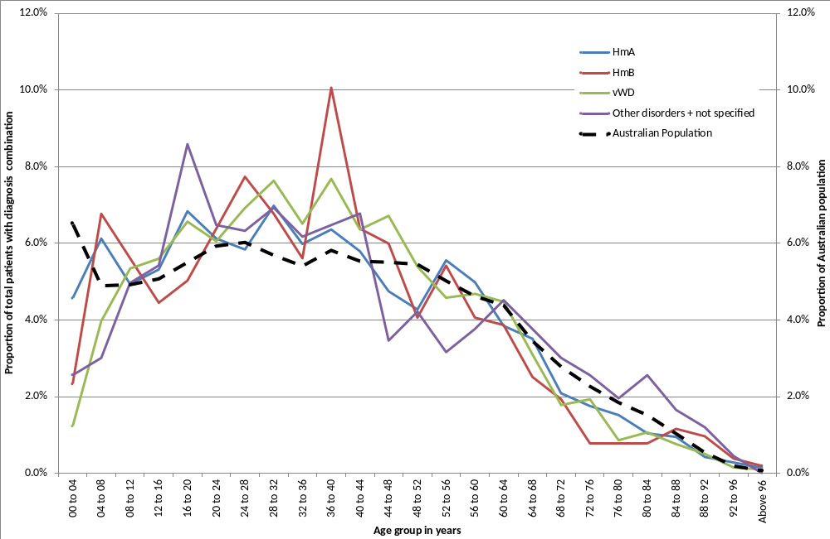
Figure 2 Age, in years, distribution of people in the ABDR by diagnosis at 30 June 2011
Figure 2 illustrates that the proportion of patients with all disorders currently aged between 35-40 years is higher than the proportion of the Australian population at that age group. Notably, the proportion of patients aged 5-10 with HmB and those aged between 15 and 20 with HmA are also substantially higher than the proportion of the Australian population at that age. However, the proportion of patients aged between 60 and 80 with the most common forms of bleeding disorders is substantially lower than that for the rest of the population. The proportion with ‘other bleeding’ disorders, which are more typically associated with ageing and diagnosis when undergoing associated medical treatments, is the reverse of this picture.

Table 8 von Willebrand Disease in the registry at 30 Jun 2011 by broad age group and vWD classification
 | Paediatric 0 – 19 years |  | Adult 20 years and over |  | Total
 | Number in registry at 30 Jun 2011 | Number who received product in 2010-11 | Number in registry at 30 Jun 2011 | Number who received product in 2010-11 | Number in registry at 30 Jun 2011 | Number who Received product in 2010-11
von Willebrand Disease - Uncharacterised | 101 | 2 | 418 | 11 | 519 | 13
von Willebrand Disease Type 1 | 242 | 10 | 834 | 54 | 1076 | 64
von Willebrand Disease Type 2 - Uncharacterised | 41 | 5 | 77 | 11 | 118 | 16
von Willebrand Disease Type 2A | 13 | 2 | 52 | 10 | 65 | 12
von Willebrand Disease Type 2B | 9 | 1 | 34 | 7 | 43 | 8
von Willebrand Disease Type 2M | 25 | 3 | 48 | 7 | 73 | 10
von Willebrand Disease Type 2N | 1 | 0 | 20 | 3 | 21 | 3
von Willebrand Disease Type 3 | 14 | 6 | 29 | 19 | 43 | 25
Total | 446 | 29 | 1512 | 122 | 1958 | 151
Notes: As noted in Box 1 the historical data has been revised from the 2009-10 report to give a more accurate indication of trends.
vWD is typically a mild disorder and data collected within the ABDR represents only a proportion of the total population affected with vWD. The primary purpose of ABDR is to record the use of products (in this case plasma derived FVIII) and a higher proportion of these patients will be Type 2/3 compared to Type 1. Type 3 is overrepresented as they are the most likely patients to have treatment and prophylaxis.
These data will be interesting to track over time as there is now an increased awareness of this disease and it is often diagnosed during surgical interventions. As the population ages and seeks more surgical intervention, more von Willebrand patients are likely to be diagnosed, treated and included in the ABDR.

Table 9 Comparison of the proportion of patients in the registry and treated, UK and Australia, major diagnoses 2011
 | Female |  |  | Male
 | Number in registry at 30 Jun 2011 | Number who received product in 2010-11 | Proportion treated | Number in registry at 30 Jun 2011 | Number who received product in 2010-11 | Proportion treated
Australia
HmA | 337 | 25 | 7.4% | 1772 | 833 | 47.0%
HmB | 97 | 13 | 13.4% | 420 | 172 | 41.0%
vWD | 1135 | 90 | 7.9% | 831 | 63 | 7.6%
Other conditions | 337 | 15 | 4.5% | 329 | 17 | 5.2%
UK†
HmA | 1119 | 63 | 5.6% | 5372 | 2919 | 54.3%
HmB | 347 | 47 | 13.5% | 1134 | 611 | 53.9%
vWD | 5770 | 666 | 11.6% | 3342 | 386 | 11.6%
Notes: † The UK’s reporting year is 1 April to 30 March whereas Australia’s 1 July to 30 June.
The UK population is approximately three times that of Australia. The treatment rates shown in Table 9 are comparable between Australia and the UK although on current data, the proportion of Australian HmB patients receiving product does appear lower. The incidence of most conditions seems higher in the UK than Australia. This may reflect some patients’ participation in clinical trials which would mean that their treatment may not be recorded in the ABDR.

By geography
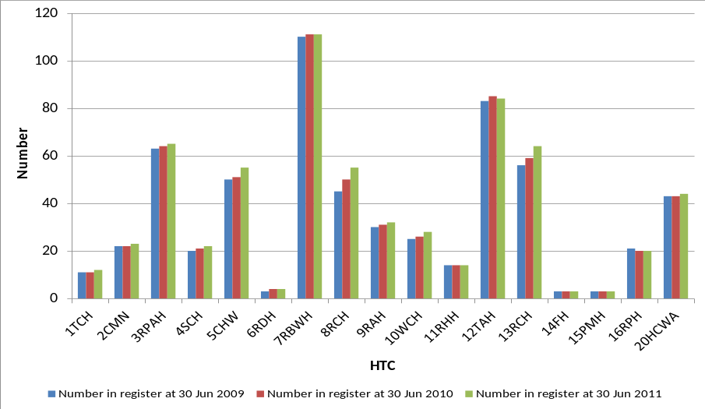
Figure 3 Distribution of severe Haemophilia A patients by Primary HTC by year
Note: Some records in the database, for Western Australia, are still recoded to against the old HTC codes rather than the new 20HCWA.
Some data in this table may contain a small number of duplicate records. These will form part of the data quality focus in 2012.

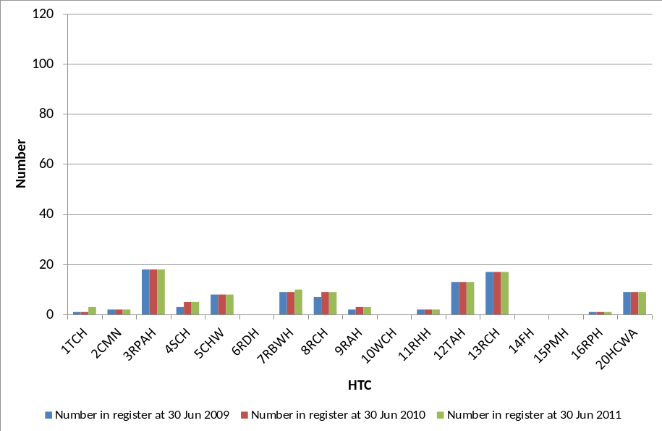
Figure 4 Distribution of severe Haemophilia B patients by Primary HTC by year
Note: Some records in the database, for Western Australia, are still recoded to against the old HTC codes rather than the new 20HCWA.

The figures above illustrate variability in the numbers of severe patients registered in each HTC mainly reflecting their catchment size and modest growth in numbers of severe patient numbers over time.
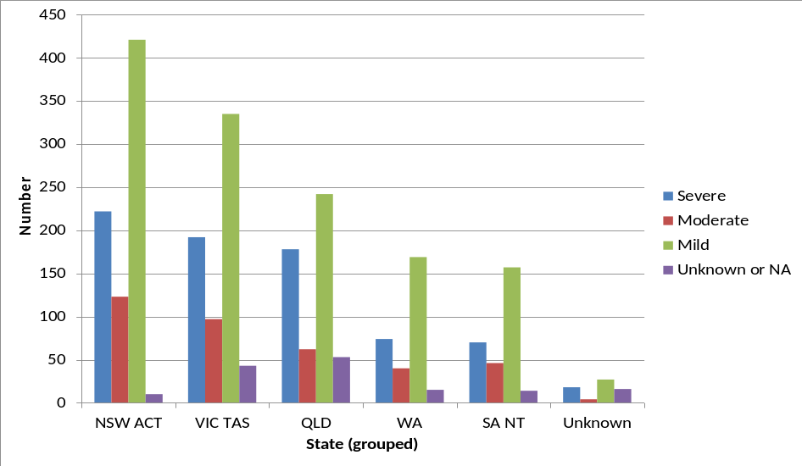
Figure 5 People in the registry at 30 June 2011 with Haemophilia A or Haemophilia B by severity and home jurisdiction (grouping small jurisdictions)
Figure 5 illustrates that numbers of patients with haemophilia are largely consistent with population size. The category ‘unknown’ includes patients who may be temporally overseas and patients who have less severe conditions and have not had recent contact with their HTC.

Incidence of major disorders
shows that Haemophilia A in males has the highest incidence with nearly 15 per 100,000 males. The next highest incidence is for von Willebrand disease in females at nearly 9 per 100,000.
Table 10 Incidence of major disorders in Australia people with bleeding disorders per 100,000 of relevant population
 | Female |  |  | Male |  |  | Persons
 | In registry at 30 Jun 2009 | In registry at 30 Jun 2010 | In registry at 30 Jun 2011 | In registry at 30 Jun 2009 | In registry at 30 Jun 2010 | In registry at 30 Jun 2011 | In registry at 30 Jun 2009 | In registry at 30 Jun 2010 | In registry at 30 Jun 2011
HmA all | 2.5 | 2.7 | 3.0 | 15.0 | 15.4 | 15.7 | 8.7 | 9.0 | 9.3
HmA severe | 0.1 | 0.1 | 0.1 | 5.5 | 5.5 | 5.6 | 2.8 | 2.8 | 2.9
HmB all | 0.7 | 0.7 | 0.9 | 3.6 | 3.7 | 3.7 | 2.1 | 2.2 | 2.3
vWD all | 8.9 | 9.5 | 10.0 | 6.7 | 7.1 | 7.4 | 7.8 | 8.3 | 8.7
The numbers in are calculated by dividing the number of people in the registry at the date with the broad diagnoses by the total corresponding Australian estimates population at the same date and multiplying by 100,000
Table 11 Incidence of bleeding disorders selected countries 2009 (per 100,000)
Country | Population | Number of PWH (HmA or HmB) | Number of people with vWD | Number of people with OBD | Number of PWH per 100,000 | Number of people with vWD per 100,000 | Number of people with OBD per 100,000
Australia | 21,515,754 | 2,283 | 1,904 | 1,652 | 10.6 | 8.8 | 7.7
France | 64,057,792 | 5,153 | 1,017 | 320 | 8.0 | 1.6 | 0.5
Germany | 82,282,988 | 4,230 | 4,674 | – | 5.1 | 5.7 | –
Netherlands | 16,783,092 | 1,397 | 257 | 65 | 8.3 | 1.5 | 0.4
Spain | 40,548,753 | 1,985 | 710 | 210 | 4.9 | 1.8 | 0.5
Sweden | 9,074,055 | 1,020 | 1,538 | – | 11.2 | 16.9 | –
United Kingdom | 61,284,806 | 6,460 | 8,773 | 6,308 | 10.5 | 14.3 | 10.3
United States | 310,232,863 | 16,667 | 12,524 | 1,607 | 5.4 | 4.0 | 0.5
Source: World Federation Hemophilia Report on the annual global survey 2009

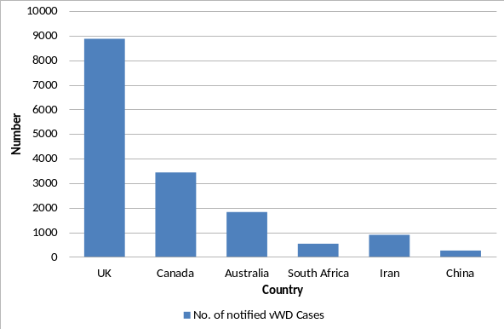 | 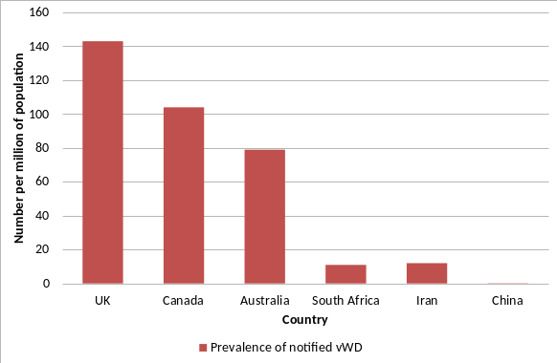
Source: Favaloro EJ, von Willebrand Disease: Local Diagnosis and management of a Globally Distributed Bleeding Disorder; Semin Thromb Hemost (2011) V 37:440-455
Figure 6 Number and prevalence of notified vWD Cases (Source Population) Registry Data

Table 12 Incidence of Haemophilia A in males in OECD countries (per 100,000)
Country | 1998 | 1999 | 2000 | 2001 | 2002 | 2003 | 2004 | 2005 | 2006 | Mean
Iceland | 37.7 | NA | NA | 39.4 | NA | 39.3 | 38.1 | 38.5 | NA | 38.6
United Kingdom | 19.0 | 19.4 | 17.4 | 17.6 | NA | 17.2 | NA | 22.6 | 20.7 | 19.1
Netherlands | 15.3 | 16.0 | 15.9 | 17.7 | NA | 17.5 | 18.6 | 18.0 | 18.5 | 17.2
New Zealand | 18.5 | 17.0 | 16.7 | 21.6 | NA | 17.8 | 11.7 | 12.3 | 21.9 | 17.2
Ireland | 12.5 | 16.5 | 17.5 | 16.7 | NA | 16.6 | 17.8 | 18.9 | 18.3 | 16.8
Sweden | 15.5 | 16.2 | 14.9 | NA | NA | 14.9 | 15.0 | NA | NA | 15.3
Switzerland | 14.5 | 13.3 | 14.6 | 11.9 | NA | 12.1 | 13.2 | 12.7 | 14.2 | 13.3
Canada | 11.9 | 13.1 | 12.6 | 12.5 | 12.4 | NA | 14.0 | 14.3 | 14.6 | 13.2
Denmark | 11.8 | 11.8 | 12.5 | 12.4 | NA | 12.6 | 12.1 | 13.1 | NA | 12.3
Czech Republic | 12.2 | 12.2 | 12.2 | NA | NA | NA | NA | NA | NA | 12.2
France | 12.7 | 12.7 | 14.8 | NA | NA | NA | NA | 9.8 | 11.0 | 12.2
Greece | 10.7 | 10.8 | 12.2 | 12.4 | NA | 12.4 | 12.8 | 13.0 | 13.0 | 12.2
Belgium | 10.5 | 11.8 | 12.1 | 12.4 | 12.4 | 12.3 | NA | NA | NA | 11.9
Norway | 11.6 | 11.5 | 11.6 | NA | NA | 11.9 | NA | 12.3 | 12.2 | 11.9
Italy | 9.0 | 12.3 | NA | NA | NA | NA | 13.8 | 13.8 | 9.4 | 11.7
Australia | 10.8 | 10.6 | 10.5 | 10.4 | NA | NA | 8.8 | 12.8 | 13.5 | 11.1
Luxembourg | 10.0 | 9.0 | 13.5 | NA | NA | NA | NA | NA | NA | 10.8
Germany | NA | 13.2 | 9.6 | 9.8 | NA | 10.0 | 10.0 | 10.0 | 10.0 | 10.4
Portugal | 8.7 | 8.7 | 8.7 | 8.6 | NA | 10.3 | 9.6 | 9.6 | 9.7 | 9.2
Finland | NA | NA | NA | NA | NA | 8.6 | NA | 9.0 | 9.1 | 8.9
Spain | 10.9 | 8.5 | 8.5 | 10.0 | NA | 9.7 | 7.6 | 7.6 | 7.6 | 8.8
Austria | NA | 8.4 | 8.4 | NA | NA | 8.7 | 8.7 | NA | NA | 8.5
United States | 7.6 | 7.5 | 7.7 | 7.8 | NA | 7.6 | 7.8 | 7.9 | 8.0 | 7.8
Japan | 5.3 | 5.5 | NA | 5.9 | NA | 6.2 | NA | 6.3 | 6.5 | 5.9
Korea | 4.7 | 5.0 | 5.2 | 5.3 | 5.3 | NA | 5.5 | 5.8 | 5.9 | 5.3
Source: World Federation of Hemophilia – Facts and figures (December 2010)
Table 12 shows that of the OECD countries Australia is placed in the middle for documented incidence of Haemophilia A.
Table 13 Incidence of Haemophilia A in males in selected countries by severity (per 100,000)
Country | Year | Overall | Severe | Severe as a proportion of overall
Canada | 2008 | 14.3 | 4.3 | 30%
Greece | 1992 | 12.0 | 3.6 | 30%
Italy | 2006 | 9.5 | 4.8 | 51%
Netherlands | 2001 | 11.7 | NA | NA
United Kingdom | 2008 | 21.5 | 7.1 | 33%
United States | 1998 | 10.4 | 4.4 | 42%
Australia – In registry (current ABDR at 30 June) | 2011 | 15.7 | 5.6 | 36%
Source: World Federation of Hemophilia – Facts and figures (December 2010); ABDR
Table 13 shows that proportion of severe cases in Australia is broadly comparable to other countries.

By age distribution
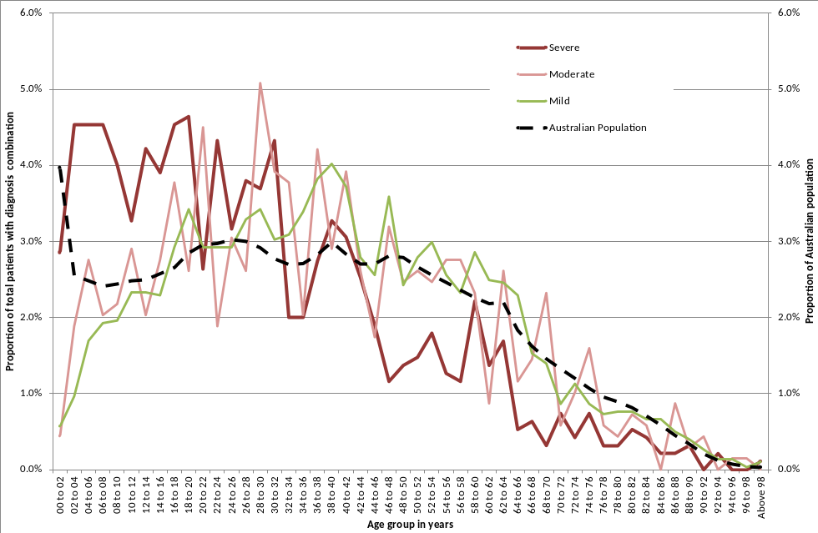
Figure 7 Age distribution of people in the registry at 30 June 2011 by severity
In Figure 7 we see that the age distribution of those living with severe diagnosis is much younger than the other groups and the Australian population as a whole. There is also a dip in the distribution of the severe group around the ages between 40 and 50. The higher proportion at younger ages reflects early diagnosis of the more severely affected. Note severity is not applied consistently for von Willebrand patients. Figure 8 show the age distribution for HmA and HmB only where there is a more consistent definition of severity applied.
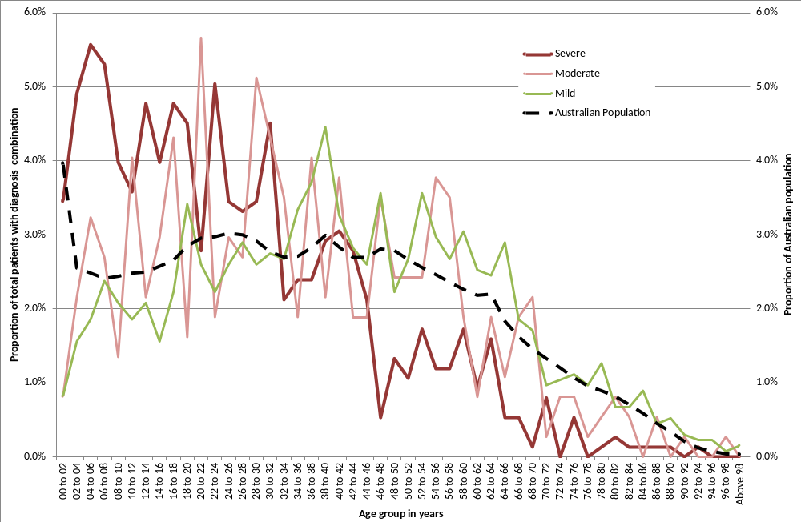
Figure 8 Age distribution of people in the registry at 30 June 2011 with Haemophilia A and Haemophilia B by severity

By Inhibitors
Table 14 Number of patients with inhibitors and comparison with UK in 2010-11
 | Severe |  |  | Moderate |  |  | Mild |  |  | Total
 | Inhibitor present | Proportion of total with inhibitors | Total Severe | Inhibitor present | Proportion of total with inhibitors | Total Moderate | Inhibitor present | Proportion of total with inhibitors | Total Mild† | Proportion of total with inhibitors | Total in Registry at 2011
Australia
HmA | 133 | 20.4% | 651 | 15 | 5.7% | 261 | 37 | 3.4% | 1075 | 9.3% | 1987
HmB | 7 | 6.8% | 103 | 0 | 0.0% | 111 | 0 | 0.0% | 276 | 1.4% | 490
vWD‡ | 2 | 1.4% | 138 | 0 | 0.0% | 251 | 0 | 0.0% | 1577 | 0.1% | 1966
UK
HmA | 374 | 20.1% | 1860 | 36 | 6.7% | 534 | 59 | 2.0% | 2976 | 8.7% | 5370
HmB | 15 | 3.7% | 401 | 0 | 0.0% | 244 | 1 | 0.2% | 486 | 1.4% | 1131
vWD | 6 | 4.8% | 125 | 2 | 1.2% | 161 | 4 | 0.1% | 8214 | 0.1% | 8500
† For vWD severity is not always defined. Included in the mild vWD are those with severity ‘mild’, ‘not applicable’ and ‘unknown’.
‡ Inhibitors are usually only seen in type 3 (severe) VWD - so if the number of type 3(31) were to be used then becomes similar to UK proportion

There is some concern at the data entry consistency in this field, however, the Australian data appears broadly comparable with the UK data.
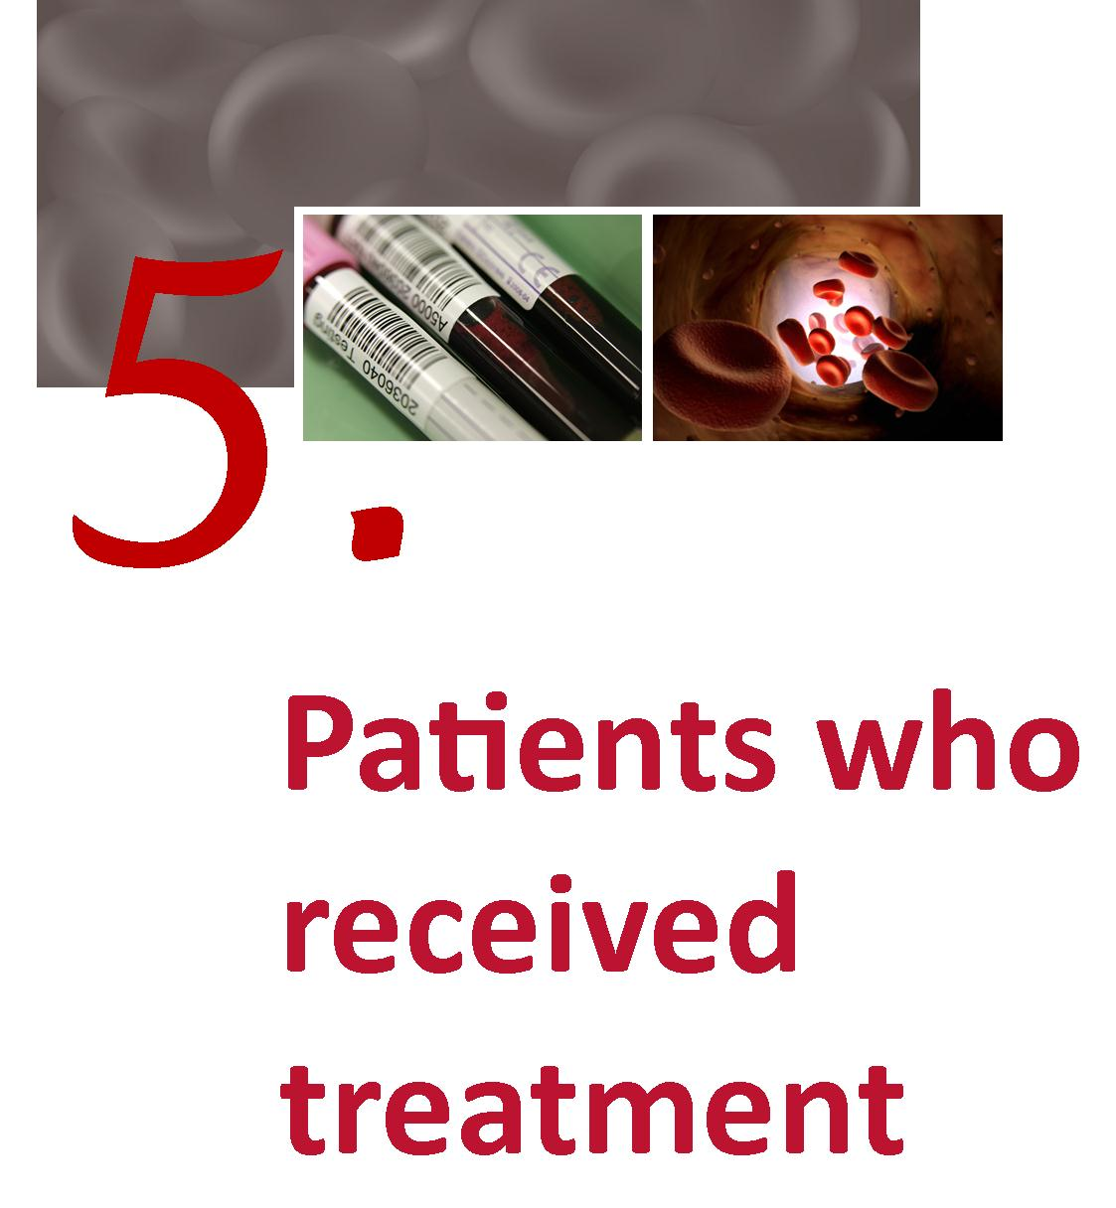

Patients who received treatment
The following graphs are based on product use reported in the ABDR

By severity
As would be expected, more severe patients are treated more often and receive more product. It is important for supply planning purposes to understand trends in the proportion of patients diagnosed as severe to ensure adequacy of supply and likely demand in the future.
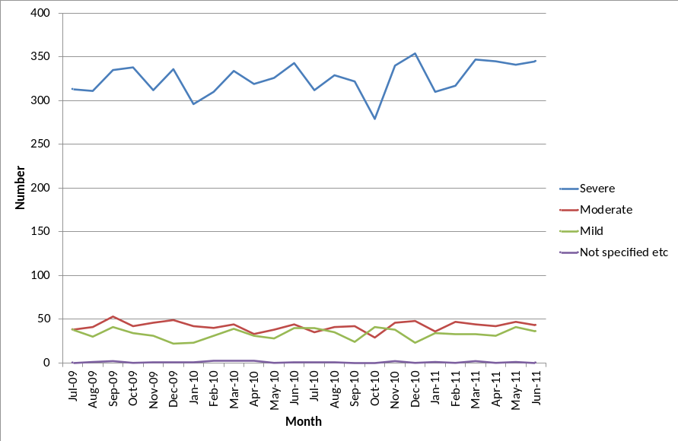
Source: ABDR
Figure 9 HmA (Symp + Asymp) – Number of patients receiving treatment by severity

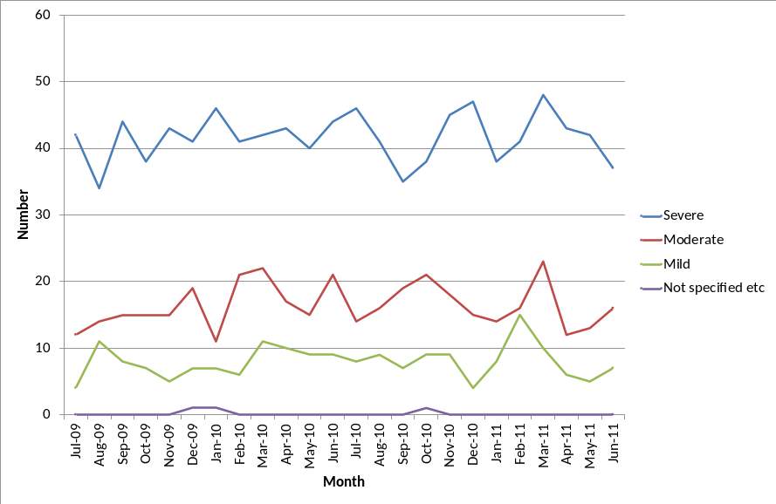
Source: ABDR
Figure 10 HmB (Symp + Asymp) – Number of patients receiving treatment by severity

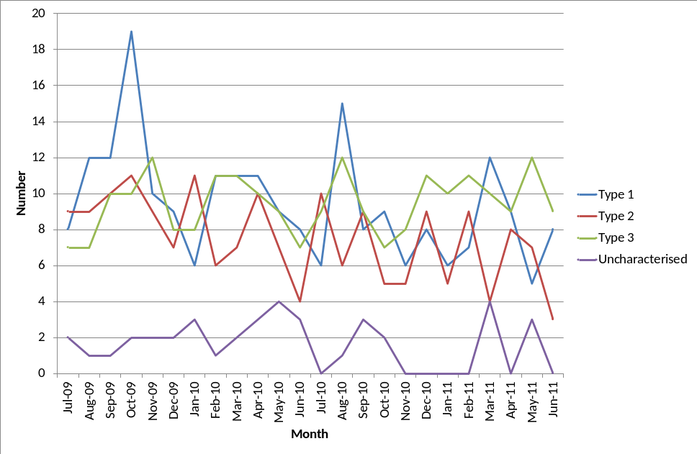
Source: ABDR
Figure 11 vWD – Number of patients receiving treatment by type of vWD

As would be expected, a higher proportion of those patients with severe diagnosis, receive treatment during the year although the pattern for patients with vWD is less predictable than other diagnoses as numbers are small. Note that many patients with vWD particularly Type 1 will receive DDAVP.
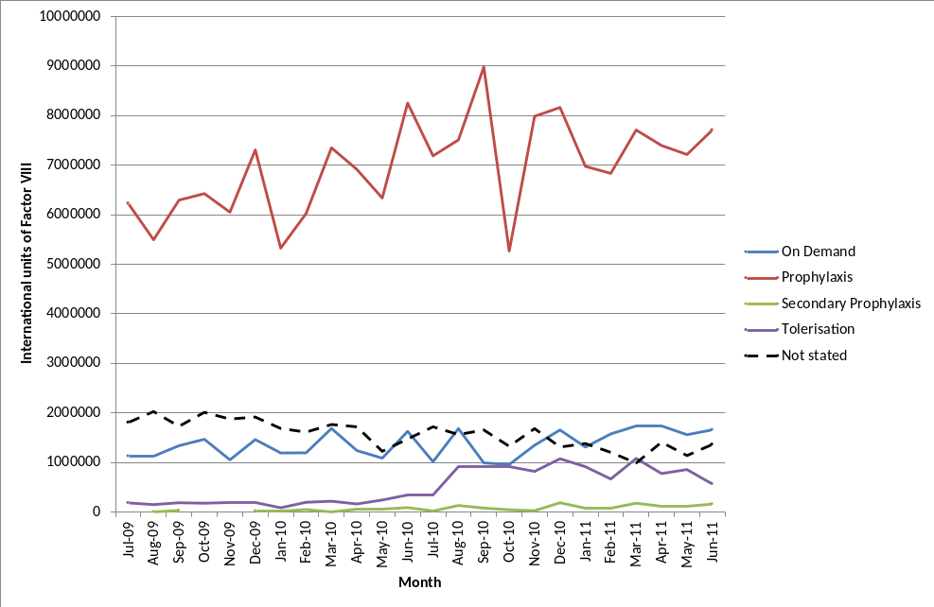
Source: ABDR
Figure 12 International Units of FVIII received by HmA patients by treatment regimen

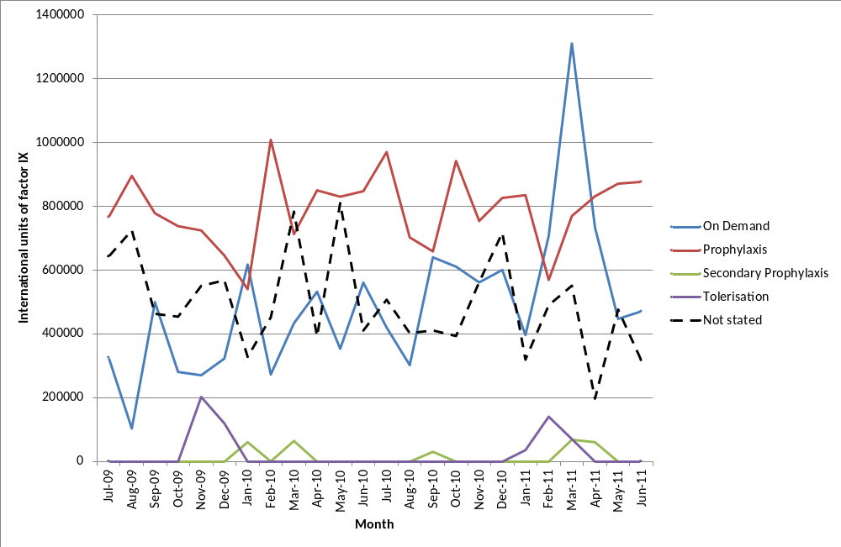
Source: ABDR
Figure 13 International Units of FIX received by HmB patients by treatment regimen
Figure 12 and Figure 13 show the impact of prophylaxis on the volume of clotting factors used in the treatment of people with haemophilia. For Haemophilia A, most of the product is used for prophylaxis.
Last year’s report included a section on use by treatment purpose. This year’s report does not include a section based on purpose due to the ongoing concerns of the data quality and difficulties in consistently coding the purpose field. The purpose field in the ABDR still needs further clarification. The classifications by purpose currently provided are not mutually exclusive and some patients may have been counted more than once. Further, different HTCs or clinicians may interpret them differently. The definitions and data entry protocols will be an area of focus for future work. A likely revamp of this field will be to record this information by:
- Location – home or hospital
- Regimen – prophylaxis or on demand
- Purpose – bleed, surgery, procedure or prevention (prophylaxis).

National average issues of Factor VIII by severity
There are many other factors affecting the use of product including body weight and severity. Figure 14 shows the average issue of factor VIII by severity by jurisdiction. The more severe the condition is, the greater the amount of product given. Moreover, there is considerable difference between the jurisdictions.
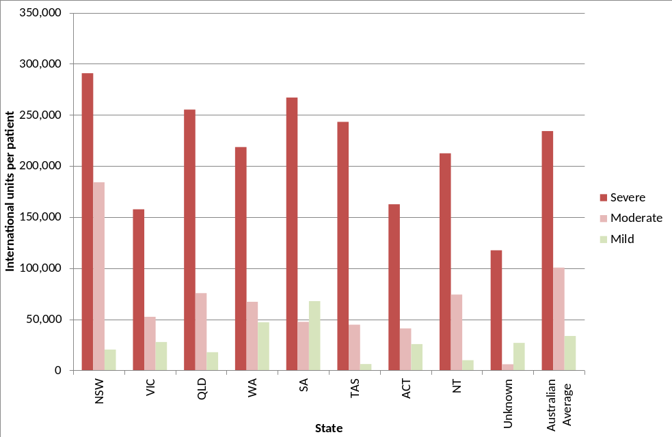†
Only patients who received Factor VIII in 2010-11 are included.
Figure 14 Mean units per Haemophilia A patient† of Factor VIII recorded in the ABDR by home jurisdiction of patient and severity in 2010-11

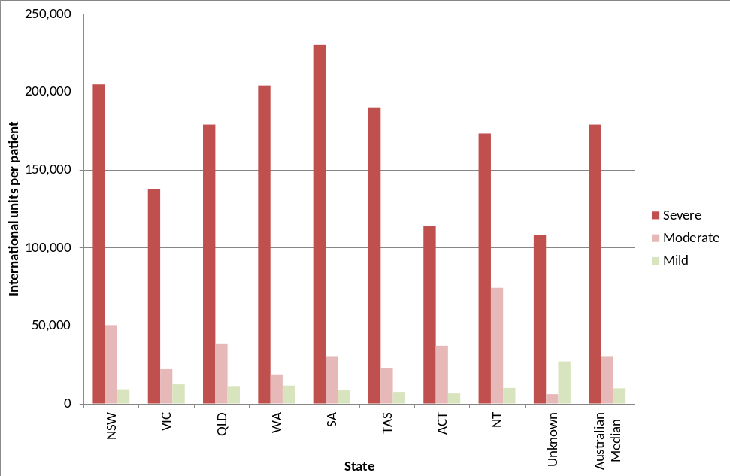
Note: Unknown: Where location, as at the time of reporting was indeterminate
† Only patients who received Factor VIII in 2010-11 are included.
Figure 15 Median Factor VIII per Haemophilia A patient† by jurisdiction and severity in 2010-11
The mean is larger than the median because it is distorted by small numbers of people receiving very large amounts of clotting factor such as those undergoing tolerisation. The median is considered a more robust measure of the ‘average’ dosage.
Table 15 Issues of Factor VIII to Haemophilia A patients UK and Australia in 2010-11
 | United Kingdom |  |  | Australia
 | Number treated | Total units of FVIII | Units per patient | Number treated | Total units of FVIII | Units per patient
Severe HmA | 1,657 | 390,678,763 | 235,775 | 485 | 113,593,000 | 234,212
Non severe HmA | 1,068 | 58,570,945 | 54,842 | 347 | 20,454,000 | 58,945
Tot HmA | 2725 | 449,249,708 | 164,862 | 832 | 134,047,000 | 161,114

By weight and height

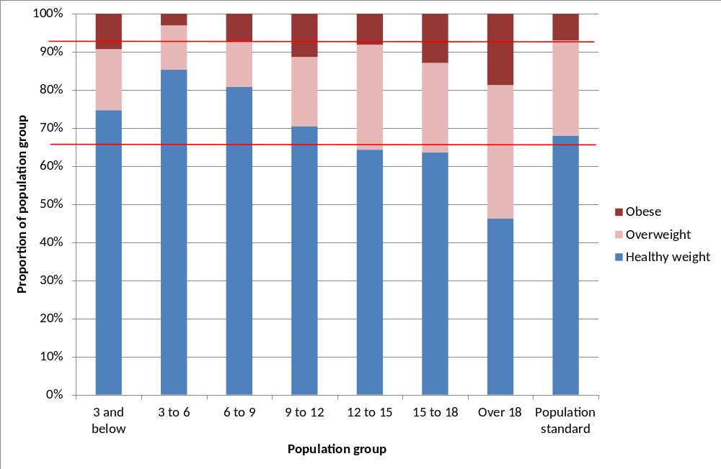
Source: ABDR and Victorian Department of Health
Figure 16 Weight and height data for ABDR patients receiving treatment in 2010-11
Figure 16 was constructed using age, weight and height data collected in ABDR. These data were combined to calculate the body mass index (BMI). The calculated BMIs were compared with an age appropriate BMI scale produced by Victorian Department of Health to determine whether the BMI corresponded to that patient being overweight or obese. Generally 25 per cent of the population are considered overweight and 7 per cent obese. These data may not be fully representative for adult patients as the height and weight data is less complete for them. As dosage is often related to weight, high proportions of overweight and obese patients may lead to an increase in the rate of growth of demand for products.

By age distribution
The following section shows the age distribution of patients who received product in at least one of the last two financial years.
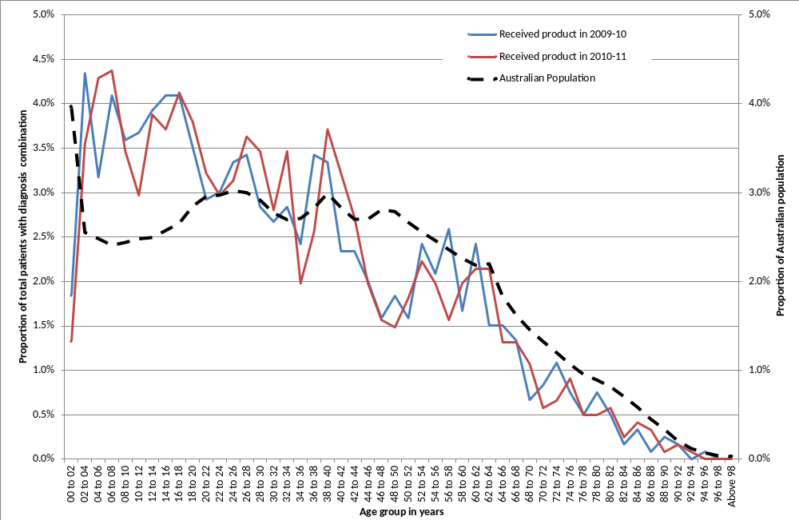
Source: ABDR and ABS Population statistics
Figure 17 Age distribution of patients who received treatment in 2009-10 or 2010-11 compared with the Australian population
Figure 17 shows that those patients in the ABDR who are receiving treatment are generally younger than the Australian population as a whole. Also of note is the dip in the distribution at patients aged around 40 to 50. These distributions are similar to that for patients with severe conditions in Figure 7 and Figure 8.
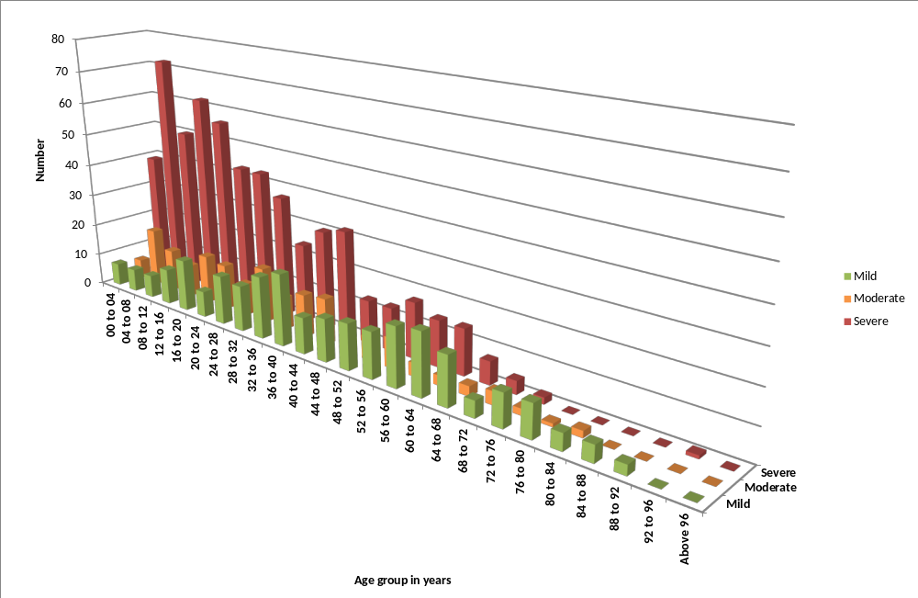
Figure 18 Age distribution at 30 June 2011 of Haemophilia A and Haemophilia B patients who received product in 2010-11
Figure 18 shows a large proportion of the severe Haemophilia A and Haemophilia B population are in the younger age groups. If the higher numbers in the younger age groups flow into older age groups, overall growth in demand for clotting factors may be significantly impacted.
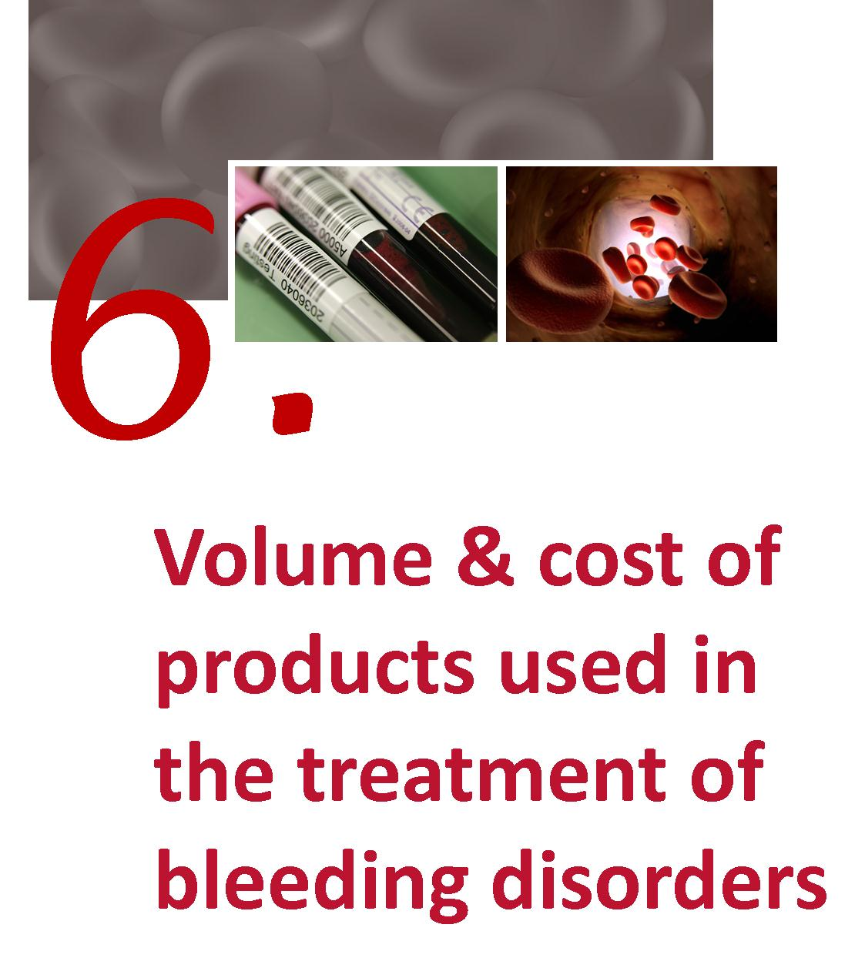

Volume and cost of products used in the treatment of bleeding disorders
Figure 19 shows both the strong growth of clotting factors used in the treatment of people with haemophilia and the even stronger growth in the use of recombinant clotting factors.

National issues by product
International Units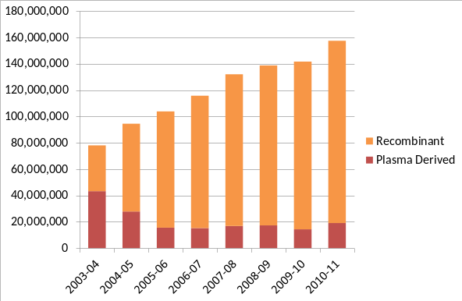 | International Units per 1000 population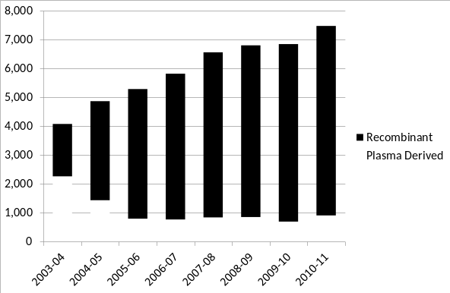
Source: IDMS database of issues
Figure 19 Annual use of Factor VIII issued nationally 2003-04 to 2010-11

This shows that demand for Factor VIII has increased by 102 per cent over the years 2003-04 to 2010-11 (an average rate of 10.5 per cent per annum) and that the growth rate from 2008-09 to 2009-10 was below trend at 2.1 per cent. This figure also illustrates the rapid uptake of recombinant product. Growth in 2010-11 for total Factor VIII issues was 11.2 per cent. It will be important to monitor the growth rate against the change in age distribution of severe patients depicted at Figure 8. As the use per 1000 population is growing, the growth in Factor VIII use is greater than population growth.
International Units 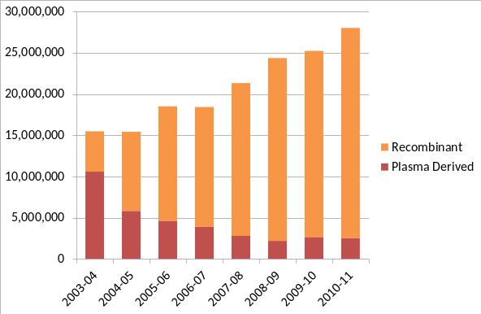 | International Units per 1000 population 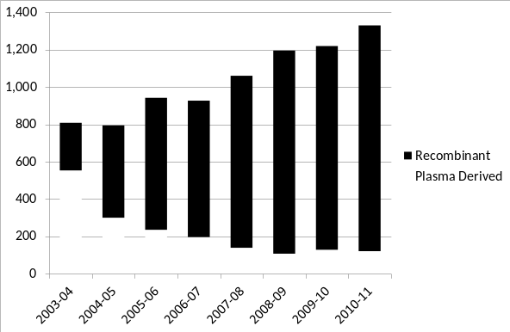
Source: IDMS database of issues.
Figure 20 Annual use units of Factor IX issued nationally 2003-04 to 2010-11
Similar to Figure 19, Figure 20 shows the strong growth of factor IX use since 2003 (81 per cent or 8.9 per cent per annum) and the substitution of recombinant for plasma derived product.

International Units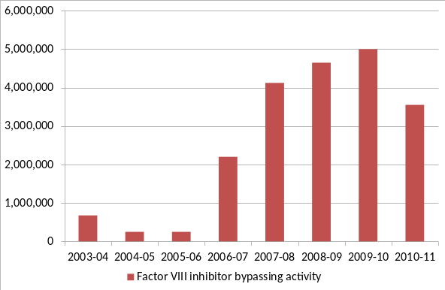 | International Units per 1000 population 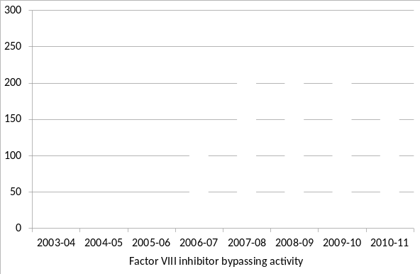
Source: IDMS database of issues.
Figure 21 Annual use of Factor VIII inhibitor Bypassing Activity (FEIBA) issued nationally 2003-04 to 2010-11

From 2005-06 to 2009-10 demand for FEIBA increased significantly; in 2005-06 approximately 251,500 IUs were issued compared with almost 4.8 million IUs in 2009-10 (Figure 21). Part of this growth relates to FEIBA becoming more widely available and government funded in 2006-07. There was a rapid fall in the use in 2010-11 with demand dropping nearly 30 per cent. Early indications for 2011-12 are that the demand for FEIBA will be lower.
Predicting or interpreting changing demand trends is not possible with any accuracy, as the product is only used in a small number of patients each year. Use patterns will vary from year to year and will not only depend on the number of patients treated, but their severity of disease, the potency of inhibitors, whether secondary prophylaxis is practiced, the number and severity of spontaneous bleeds, and the amount of elective surgery undertaken in this patient group.
FEIBA and recombinant factor VIIa (rVIIa) (brand name NovoSeven) are both used to treat patients that have developed inhibitors. In the setting of managing inhibitors for haemophilia, the drivers for clinical demand for FEIBA are similar to those for NovoSeven. The work of AHCDO in standardising protocols in haemophilia management will likely assist with driving a consistency of approach to the use of FEIBA and similar/related agents.
mg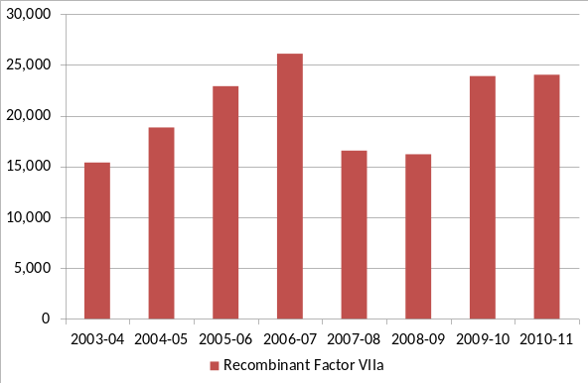 | mg per 1000 population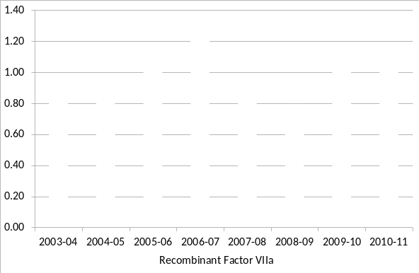
Source: IDMS database of issues.
Figure 22 Annual use of Recombinant Factor VIIa (NovoSeven) 2003-04 to 2010-11

Demand for NovoSeven to treat patients with haemophilia under the National Blood Arrangements increased sharply from 2003-04 (15,400mg) to a high point in 2006-07 (25,900mg) but then declined to a more stable level in 2007-08 and 2008-09. However, high growth (47%) has been seen again from 2008-09 to 2009-10 (Figure 22). There was little change in demand between 2009-10 and 2010-11. Demand for NovoSeven is very difficult to predict due to small patient numbers and patient specific requirements. At times very large doses can be needed by a single patient.

Reported use of Factor IX by HmB patients selected countries
The World Federation of Hemophilia collects use data from various countries. This is used to compare Australia’s use.
Table 16 The reported factor IX (FIX) use (IUs per capita) was determined from the reported number of FIX international units (IUs) used in the treatment of haemophilia B for a country from 1996 to 2006 divided by its total population in the relevant year selected countries
Country | 2003 | 2004 | 2005 | 2006 | Mean | SD | CV
Ireland | 2.7986 | 2.6055 | 2.2529 | 2.0303 | 2.1593 | 0.6412 | 30%
New Zealand | 0.5249 | 0.9387 | 1.7860 | 1.9566 | 1.2478 | 0.5584 | 45%
Sweden | 1.1888 | NA | 1.3940 | NA | 1.1722 | 0.1175 | 10%
Canada | NA | 0.9701 | 1.1289 | 1.1665 | 1.0885 | 0.1042 | 10%
United States | 0.8985 | 1.0645 | 1.0872 | 1.2446 | 0.8551 | 0.2061 | 24%
Australia | 1.3354 | NA | 0.7589 | 0.8354 | 0.7731 | 0.2790 | 36%
Denmark | 0.8909 | 0.6478 | 1.0153 | NA | 0.7364 | 0.1981 | 27%
Germany | 0.6056 | NA | 0.6050 | 0.9680 | 0.6813 | 0.1316 | 19%
Netherlands | NA | NA | 0.6124 | NA | 0.6480 | 0.2653 | 41%
United Kingdom | 0.5362 | NA | 1.0119 | 0.7606 | 0.6391 | 0.1996 | 31%
Source: J S Stonebraker, P H B Bolton-Maggs, M Brooker, A Farrugia and A Srivastava, A study of reported factor IX use around the world; WFH Fact and Figures August 2011 No 11.
The mean, standard deviation and coefficient of variation are calculated over the available years in the range 1996 to 2006. This table only shows the years 2003 to 2006.

Only the ten countries with the largest reported mean use are included in Table 16. These countries are all developed countries. Australia is ranked six in this list. As shown in Table 16, the use in Australia for 2010-10 was 1.3291 IU per patient. The three countries with the lowest reported use (Pakistan, Indonesia and Bangladesh), have mean use of no greater than 0.0005 IU per patient.

National Costs for products issued
Total expenditure on clotting factors for 2010/11 was $210.8 million. This was an increase of $22.3 million on 2009/10.
This represents approximately 23 per cent of the total blood and blood product budget for Australia in 2010/11. Expenditure by product is detailed in the NBA Annual Report, available at www.nba.gov.au and is summarised below.

Table 17 National clotting factor costs 2008-09, 2009-10 and 2010-11 in $ millions
 | 2008-09 | 2009-10 | 2010-11
Factor VIII | 104.3 | 109.3 | 128.1
Factor IX | 26.1 | 26.7 | 31.6
Recombinant Factor VIIa | 17.4 | 26.4 | 27.4
FEIBA | 13.5 | 14.5 | 10.3
Other | 12.3 | 11.5 | 13.5
Total | 173.6 | 188.5 | 210.8
Source: NBA systems

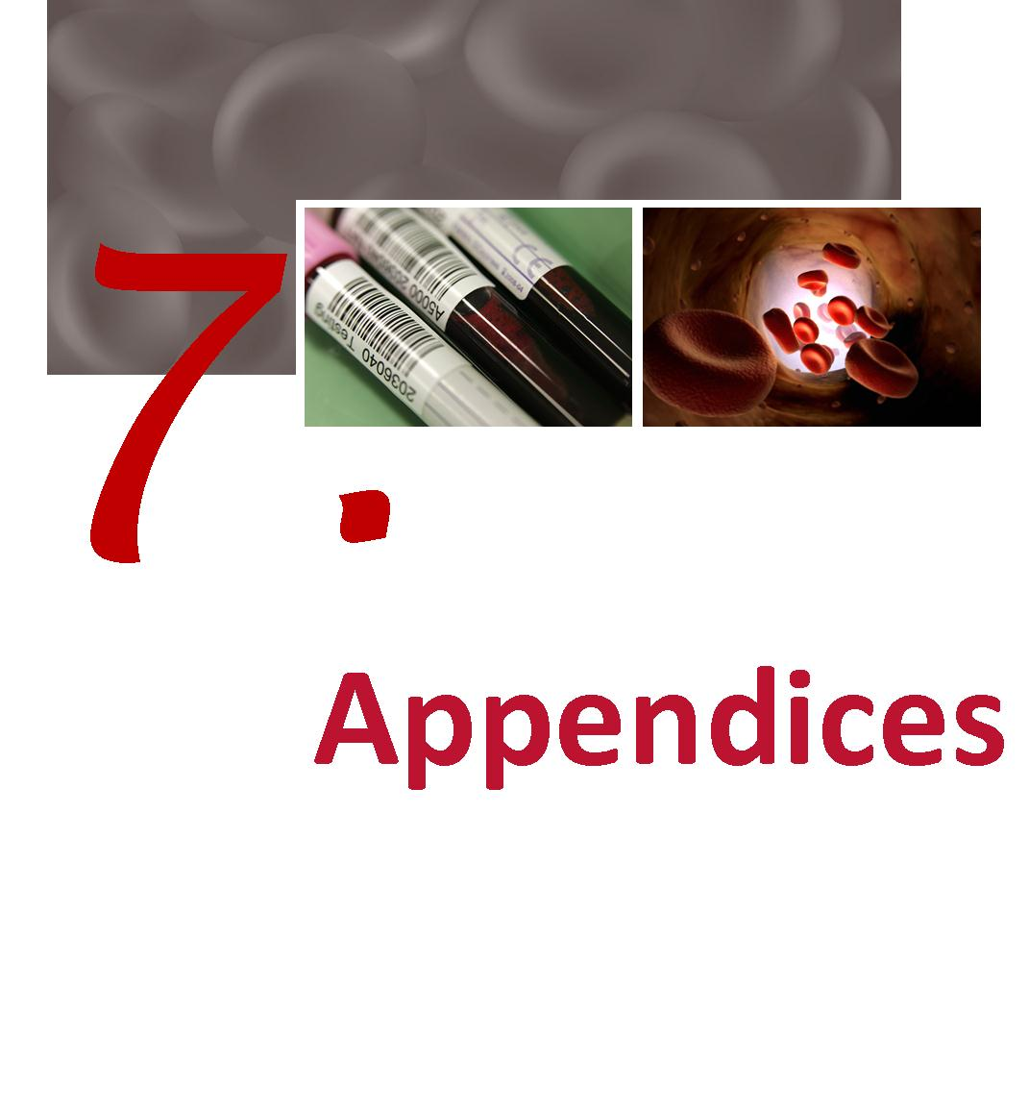

Appendices
Appendix A Haemophilia Treatment Centres
  - The objectives of HTCs
Haemophilia Centres provide comprehensive care for people with haemophilia. Their roles include:
- Compilation and distribution of guidelines for best practice directed toward optimal care of patients with disorders of haemostasis
- Providing protocols for the accurate diagnosis of patients with bleeding disorders
- Providing protocols for the regular review of infectious disease markers in patients and their families
- The allocation and distribution of therapeutic blood and recombinant products together with advice regarding the usage of blood and recombinant products, at a State and National level.
- The establishment of review programs to assess outcomes of therapies.
- Provision of regularly updated data to the national Haemophilia Registry.
- Participation in basic and clinical research
  - Operating concept
Haemophilia Centres coordinate and, where possible, integrate patient care, research and education to provide the optimal use of expertise and resources within hospitals and the community. One collaborative centre for each State and Territory may suffice but this must include adult and paediatric type centres.
The role of the Haemophilia Centres is to provide:
- a single point accountability for the care of patients with bleeding disorders with responsibility for the coordination, allocation and distribution of therapeutic resources for the treatment of patients, ie coagulation products derived either from blood donors or recombinant technologies
- a clinical service by experienced staff for patients with bleeding disorders and their families at short notice at any time of the day or night
- organisation of home therapy programs by the centre or in collaboration with other haemophilia treatment facilities.
- a counselling and advisory service for people with haemophilia and their families including genetic counselling and family planning.
- specialist medical expertise, principally haematology, surgery (the surgeons would have to be accredited to the haemophilia Centre) rheumatology, infectious diseases and dental services.
- specialist allied health services to include physiotherapy, social work and podiatry.
- a laboratory service able to carry out all investigations required for the accurate diagnosis of haemophilia and other inherited disorders of haemostasis and to have access, in association with other centres, to specialised testing facilities, for example gene typing.
- a system of record for all investigations, treatments, allocation of therapeutic products and adverse reactions.
- a capability to participate in research including clinical trials
- educational programs for medical staff, other personnel, patients and their families which promote care of patients with disorders of haemostasis.
- an outreach service to isolated patients and treating medical services. The outreach service may include:-
- A haemophilia treatment facility located in a hospital that does not provide all the specialist services
- Designated supervising medical practitioner
All isolated patients where care is managed in an outreach program should be registered at and be reviewed regularly by a Haemophilia Treatment Centre which would arrange delivery of and monitor the supply of therapeutic coagulation products.
The Centre must maintain on-going dialogue with the ‘client’ group in each State and Territory. The role of State and Territory Governments is to designate ‘Haemophilia Centres’ and negotiate the funding of the Centres including the purchase of therapeutic blood and recombinant products for distribution within States (or regions) and Territories. In some States committees have been established to consider and schedule elective surgery.
Advantages of the Proposed Model of Haemophilia Data Co-ordination
- Accurate and complete data entry
- Dedicated and focused data management
- Regular reporting and analysis of collated information
- New product initiation of unresolved haemophilia care related questions
- Clinical audit of current policies and monitoring of agreed national standards
Table 18 List of operational HTCs and their ID codes
# | Hospital | Haemophilia Treatment Centre | ID | State
1 | The Canberra Hospital | Haemophilia Clinic | 1TCH | ACT
2 | Calvary Mater Newcastle | Haemophilia Treatment Centre | 2CMN | NSW
3 | Royal Prince Alfred Hospital | Haemophilia Treatment Centre | 3RPAH | NSW
4 | Sydney Children’s Hospital | Centre for Children's Cancer and Blood Disorders | 4SCH | NSW
5 | The Children’s Hospital at Westmead | Haemophilia Treatment Centre | 5CHW | NSW
6 | Royal Darwin Hospital | Haemophilia Treatment Centre | 6RDH | NT
7 | Royal Brisbane and Women’s Hospital | Queensland Haemophilia Centre | 7RBWH | QLD
8 | Royal Children’s Hospital | Queensland Haemophilia Centre Child and Adolescent Service | 8RCH | QLD
9 | Royal Adelaide Hospital | South Australia Haemophilia Treatment Centre | 9RAH | SA
10 | Women’s and Children’s Hospital | South Australia Haemophilia Treatment Centre | 10WCH | SA
11 | Royal Hobart Hospital | Tasmanian Haemophilia Treatment Centre | 11RHH | TAS
12 | The Alfred Hospital | Ronald Sawyers Haemophilia Centre | 12TAH | VIC
13 | Royal Children’s Hospital | Henry Ekert Haemophilia Treatment Centre | 13RCH | VIC
20 | The Haemophilia Centre of WA | Incorporating:  - Fremantle Hospital  - Princess Margaret Hospital  - Royal Perth Hospital | 20HCWA | WA
99 | NBA | Offshore Patient - Long Term | 99OPL | ACT
98 | Inactive Patients | Inactive Patients | 98DPG | ACT

  - Data Quality of HTC data collections
The following organisations are represented at various HTCs nationally:
- Australian Haemophilia Nurses Group (AHNG)
- Australia/New Zealand Haemophilia Social Workers’ and Counsellors’ Group (ANZHSWCG)
- Australia/New Zealand Physiotherapist Group (ANZHPG)
- Haemophilia Foundation of Australia (HFA)
These member representatives have provided input into the initial design of the ABDR and continue to provide input from their respective areas of specialty.
The Data Managers at each HTC have elected Data Manager Co-Chairs. These Co-Chairs coordinate teleconferences, between all Data Managers, on a regular basis. The Data Manager Co-Chairs also have the functionality of raising issues, to the NBA, on behalf of their group. ACHDO has a major role in providing support to ABDR Data Managers through the funded model for Data Managers.
Data Quality initiatives implemented in 2010-11 include:
- Regular teleconferences for ABDR Data Manager Group (DMG)
- ‘Advanced Search’ functionality of the ABDR whereby Data Managers are able to extract information from the ABDR on an ad hoc basis. ‘Work around’ strategies have been developed to deal with data validity issues.
- Review of data definitions undertaken by DMG Co Chairs
- NBA financial support, through AHCDO funding, for HTC Data Managers
- The ABDR Update is a functional tool in the form of a Newsletter. This provides an update on issues such as changes to the ABDR and functionality enhancements. This update is a means of keeping all ABDR stakeholders informed.

Data Quality initiatives in 2010-11 have addressed:
- Currency of data
- Unpopulated data fields, particularly citizenship, nationality and ethnicity data fields
- National consistency of data quality
- On-going issues of information exchange when persons with haemophilia (PWH) move between states and haemophilia treatment centres
- Historical data (immediately prior to the deployment of the redeveloped ABDR in December 2008
- Timely entry of product order timeframes

Appendix B History and development of the ABDR
The ABDR was first established in 1988 using a ‘Paradox’ database at each Haemophilia Treatment Centre in Australia. The aims of the ABDR were to provide a clinical tool for improved management and national demographics of patients with haemophilia and other inherited bleeding disorders.
In 2000, a revised ABDR was established using ‘Access’ database platform at each Haemophilia Treatment Centre with a national collection of de-identified data every six months. Dedicated data base managers in individual centres improved data collection. On-going concerns regarding privacy prevented collection of national demographics such as age and gender.
To provide better sharing and access to the database it was decided in 2006 to move to an internet interface to central database. Genix Ventures was the successful tender with all Australian governments providing funding and the National Blood Authority providing the project management.
The redeveloped ABDR was deployed in December 2008 at all HTCs.
  - Benefits of the redeveloped ABDR
The NBA redeveloped the ABDR and deployed the redeveloped ABDR in December 2008. It provides the following benefits:
- Single point of access for clinicians for treatment of patients
- Patient information relating to all clinical information associated with the treatment of haemophilia
- Information exchange between states and Haemophilia Treatment Centres
- National demographic information (age, gender etc) of persons with bleeding disorders
- National data on inhibitor incidence and outcomes of treatment
- Allied health (physiotherapy and social work) monitoring and outcomes
- Recording of personal usage of factor replacement for clinical monitoring
- Data for forward planning and funding of factor concentrates on a national basis
- High usage patterns
  - Current position of the development of the ABDR
Today the Australian Bleeding Disorders Registry is fully operational. The ABDR Steering committee continues to oversee the project.
The National Blood Authority’s role continues around provision of resources to maintain ABDR operations and to ensure timely and accurate reporting from the ABDR through provision of support to Data Managers. Data Managers, funded and supported by AHCDO, are located at HTCs across Australia.
Appendix C ABDR data collection (registration form)

List of Figures
Figure 1 Location of HTCs 6
Figure 2 Age, in years, distribution of people in the ABDR by diagnosis at 30 June 2011 15
Figure 3 Distribution of severe Haemophilia A patients by Primary HTC by year 18
Figure 4 Distribution of severe Haemophilia B patients by Primary HTC by year 18
Figure 5 People in the registry at 30 June 2011 with Haemophilia A or Haemophilia B by severity and home jurisdiction (grouping small jurisdictions) 19
Figure 6 Number and prevalence of notified vWD Cases (Source Population) Registry Data 21
Figure 7 Age distribution of people in the registry at 30 June 2011 by severity 22
Figure 8 Age distribution of people in the registry at 30 June 2011 with Haemophilia A and Haemophilia B by severity 23
Figure 9 HmA (Symp + Asymp) – Number of patients receiving treatment by severity 26
Figure 10 HmB (Symp + Asymp) – Number of patients receiving treatment by severity 26
Figure 11 vWD – Number of patients receiving treatment by type of vWD 27
Figure 12 International Units of FVIII received by HmA patients by treatment regimen 27
Figure 13 International Units of FIX received by HmB patients by treatment regimen 28
Figure 14 Mean units per Haemophilia A patient† of Factor VIII recorded in the ABDR by home jurisdiction of patient and severity in 2010-11 29
Figure 15 Median Factor VIII per Haemophilia A patient† by jurisdiction and severity in 2010-11 29
Figure 16 Weight and height data for ABDR patients receiving treatment in 2010-11 30
Figure 17 Age distribution of patients who received treatment in 2009-10 or 2010-11 compared with the Australian population 31
Figure 18 Age distribution at 30 June 2011 of Haemophilia A and Haemophilia B patients who received product in 2010-11 32
Figure 19 Annual use of Factor VIII issued nationally 2003-04 to 2010-11 34
Figure 20 Annual use units of Factor IX issued nationally 2003-04 to 2010-11 34
Figure 21 Annual use of Factor VIII inhibitor Bypassing Activity (FEIBA) issued nationally 2003-04 to 2010-11 35
Figure 22 Annual use of Recombinant Factor VIIa (NovoSeven) 2003-04 to 2010-11 36

List of tables
Table 1 Major bleeding disorders and their cause 4
Table 2 Severity and the concentration of clotting factors 5
Table 3 Number of people in the register and treated by latest broad diagnosis 10
Table 4 Number of people in the register and treated by detailed diagnosis HmA, HmB and vWD 11
Table 5 Number of people in the registry and treated by diagnosis of “other disorders” 12
Table 6 Number in registry and receiving product by diagnosis of “Platelet disorders” 13
Table 7 People in the register at 30 Jun 2011 by broad age group, diagnosis and severity 14
Table 8 von Willebrand Disease in the registry at 30 Jun 2011 by broad age group and vWD classification 16
Table 9 Comparison of the proportion of patients in the registry and treated, UK and Australia, major diagnoses 2011 17
Table 10 Incidence of major disorders in Australia people with bleeding disorders per 100,000 of relevant population 19
Table 11 Incidence of bleeding disorders selected countries 2009 (per 100,000) 20
Table 12 Incidence of Haemophilia A in males in OECD countries (per 100,000) 21
Table 13 Incidence of Haemophilia A in males in selected countries by severity (per 100,000) 22
Table 14 Number of patients with inhibitors and comparison with UK in 2010-11 23
Table 15 Issues of Factor VIII to Haemophilia A patients UK and Australia in 2010-11 30
Table 16 The reported factor IX (FIX) use (IUs per capita) was determined from the reported number of FIX international units (IUs) used in the treatment of haemophilia B for a country from 1996 to 2006 divided by its total population in the relevant year selected countries 36
Table 17 National clotting factor costs 2008-09, 2009-10 and 2010-11 in $ millions 37
Table 18 List of operational HTCs and their ID codes 41

Modified from Bolton-Maggs, PH & Pasi, KJ 2003, 'Haemophilias A and B', Lancet, 361 (9371), pp. 1801–1809. See also: White GC et al. Definitions in Hemophilia: Recommendation of the Scientific Subcommittee on Factor VIII and Factor IX of the Scientific and Standardization Committee of the International Society on Thrombosis and Haemostasis. Thromb Haemost 2001;85:560.
http://www.ukhcdo.org/
PWH – people with haemophilia.
OBD – other bleeding disorders.

