Privacy Consenting Tip Sheet
The Privacy Act 1988 has been amended and important changes to the act have commenced and are being incorporated into ABDR on 26 January 2015. As part of this change the NBA has published its new privacy policy which is available at www.blood.gov.au/abdr . For detailed information on implementation at the Haematology Treatment Centre please refer to www.blood.gov.au/system/files/documents/htc-implementation-protocol.pdf.

Updates on Patient Summary Tab

If the patients’ consent status is not recorded or is saved as ‘Do Not Consent’ then the below box will appear on the left hand side patient summary tab in ABDR. This is to notify ABDR users that the patient needs to record a consent status at their next possible convenience or that if they do not consent that their data will not be editable.

New Privacy Consent Tab
Any ABDR users can add the privacy consent status in ABDR on behalf of the patient using the new Privacy Consent tab under the Patient Details section.
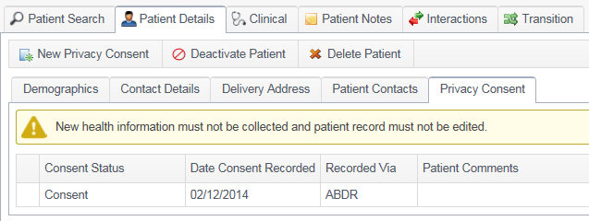
This tab can be actioned when contact is next made with the patient, but until this date any details can be added into ABDR as required.

Actioning the New Privacy Consent
Once you click on the new Privacy consent button, a page will open where privacy consent can be documented. Please choose the consent status, date of consent and add any comments as required. A file upload feature has also been provided which can be used to upload a privacy related document, such as the ABDR/MyABDR privacy collection notice and consent form available at www.blood.gov.au/system/files/documents/abdr-myabdr-privacy-collection-notice-and-consent-form.pdf.
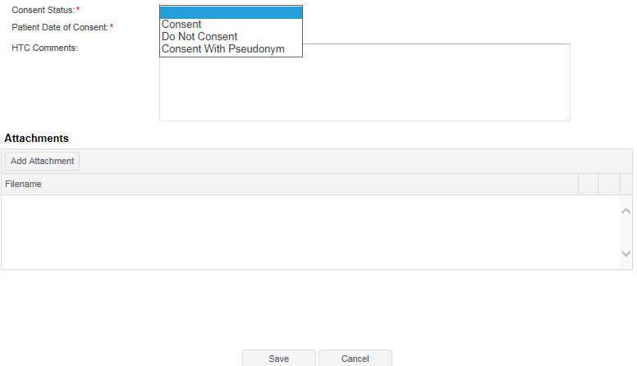
Creating a pseudonym for privacy consent provided in MyABDR

A patient may select ‘Consent with Pseudonym’. If they choose this option in MyABDR an email will be sent to the HTC to notify them of this request but the pseudonym can only be set up in ABDR.
When the ‘Consent Status’ is selected as consent with pseudonym, 2 extra fields are presented on the consent status page. These 2 fields ‘Given Name Pseudonym’ and ‘Family Name Pseudonym’ must be used to set the pseudonym for the patient.
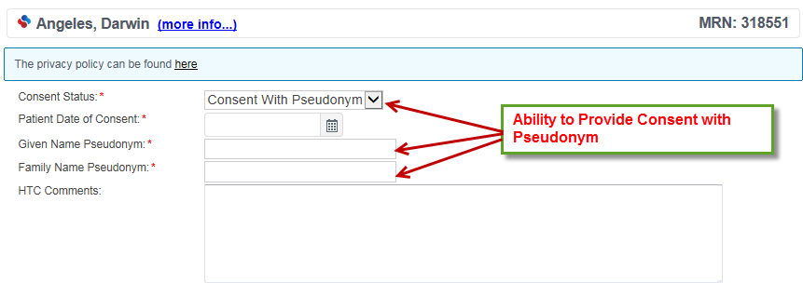

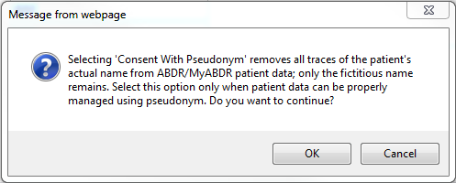
For more information on consenting with a pseudonym please go to www.blood.gov.au/privacy-info-abdr-myabdr.

Changing Consent Status
If a patient decides to change their consent status then follow the above steps to add in a new consent status with a new date.

Changing a Pseudonym
If a patient has consented with a pseudonym and has requested to change the pseudonym click on the edit button on the left hand side of the consent status line and edit the first and last name as required.
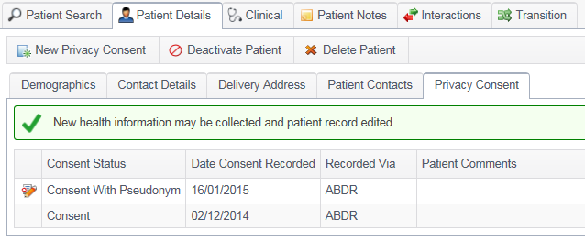

New report - ‘Privacy Consent’
A Patient Consent Report has been created under ‘Print and Report’ that shows how many patients have consented (normally), have consented with a pseudonym, have not consented or have not recorded any consent data for each HTC.

