**Last 12 Months Planned vs Ordered vs Treatment Product Usage (volume)** shows amount of product by volume planned for the patient, how much was ordered for them and how much has been used in ABDR and MyABDR Treatments.

**Report attributes in Header** shows standard details including logos, report title, security markings, Report Parameter: Month and Year selected and last time data was updated: NB Generally data is rolled up and summarised overnight, therefore some transactions will only be displayed the day after they’re updated e.g. weight changes will appear immediately but interactions will not.

**Last 10 changes to patient measurements** graphs the change in weight and weight for the last 10 changes. The date of each change is displayed on the horizontal axis.

If there has been rapid change in a short period of time the earlier changes will drop off even if they occur in a time period that you expect to see graphed.

**Patient Details** shows the patient’s address and demographic details, including patient type at your HTC and the MyABDR icon if patient is associated to a MyABDR account.

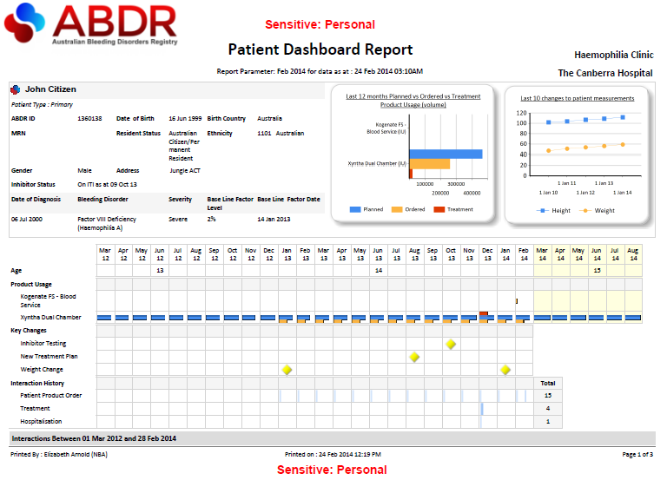

**Clinical details** displays latest Inhibitor Status information and diagnosis, showing multiple diagnoses where applicable.

**Interaction History** for each interaction that occurs in the Month and Year, a blue line appears, multiple lines are displayed and the Total number of interactions for the period shown is totaled.

**Calendar and Age** the time band shown is the previous two years from the month and year selected in the report parameters plus six months into the future from current date.

**Product Usage** shows Planned, Ordered and Treatment usage by month in the Calendar period.

**Key Changes** displays a single yellow diamond in the month that a change or changes to the patient’s clinical status occurs.

**Interactions Between DD MM YYYY and DD MM YYYY** graphs all interaction activity for the patient and displays summary information for each interaction. NOTE this is a Header with the details shown over the page when the report is generated, but are not shown in this Quick Reference Guide. Details are:  
**Interaction Counts by Type and Month** graphs the number of interactions recorded in the last 12 months; and   
**Interaction Detail** lists Interaction Date, Type and Summary for interactions shown in the graph.

**Report attributes in footer** shows standard details including security markings, date report was printed, by whom, and number of pages.