TACO Case Study
Authors: Christine Akers, Bridget Glazebrook, Linley Bielby.
A 78-year old man was admitted for left iliac artery stents. He had a history of chronic kidney disease and ischaemic cardiomyopathy (ejection fraction 38%). Three days post procedure he was transfused for symptomatic anaemia, with haemoglobin (Hb) 74 g/L. The red cell unit was charted to run over 4 hours, but was stopped at 1 hour and 40 minutes after commencement in response to the onset of respiratory wheeze, dyspnoea and reduced oxygen saturation. He was treated with oxygen and diuretics and required intensive care unit (ICU) admission. His pre-transfusion weight and fluid balance were not reported.
Investigations included a chest X-ray which showed ‘bilateral middle and lower zone patchy airspace opacities in keeping with mild alveolar oedema. Congestion of pulmonary vasculature. Normal cardio mediastinal contours. The findings suggest pulmonary oedema.’
Serological testing demonstrated the red cell unit was compatible for the patient.
The patient remained in ICU for approximately 20 hours after which he was discharged back to the ward where he remained for a further 10 days before he was discharged from the health service.
Initially the event was reported to the Blood Service as a transfusion related acute lung injury (TRALI) who reclassified and confirmed this as a transfusion associated circulatory overload (TACO) event. The health service reported the event to the Serious Transfusion Incident Reporting (STIR) system as TACO. STIR confirmed the event as TACO with an imputability of probable (when the evidence is clearly in favour of attributing the incident to the transfusion), and a severity rating 1 (result in, or have the realistic potential to result in, an unexpected death or a permanent and disabling injury or psychological harm to a person).
TACO is often under-reported unless, like this case, there are serious consequences to the patient.
STIR recommends, unless required to treat life-threatening bleeding, a slow infusion rate should be used for all blood products especially for high risk patients to minimise the risk of reactions such as TACO and allergic reactions. Patients need to be monitored closely throughout the transfusion for early signs of overload. Single unit transfusions are recommended where patients are not actively bleeding.
Clinicians should consider the use of pre-transfusion risk assessment tools for TACO to reduce the likelihood of TACO occurring, such as the example provided by Blood Matters.
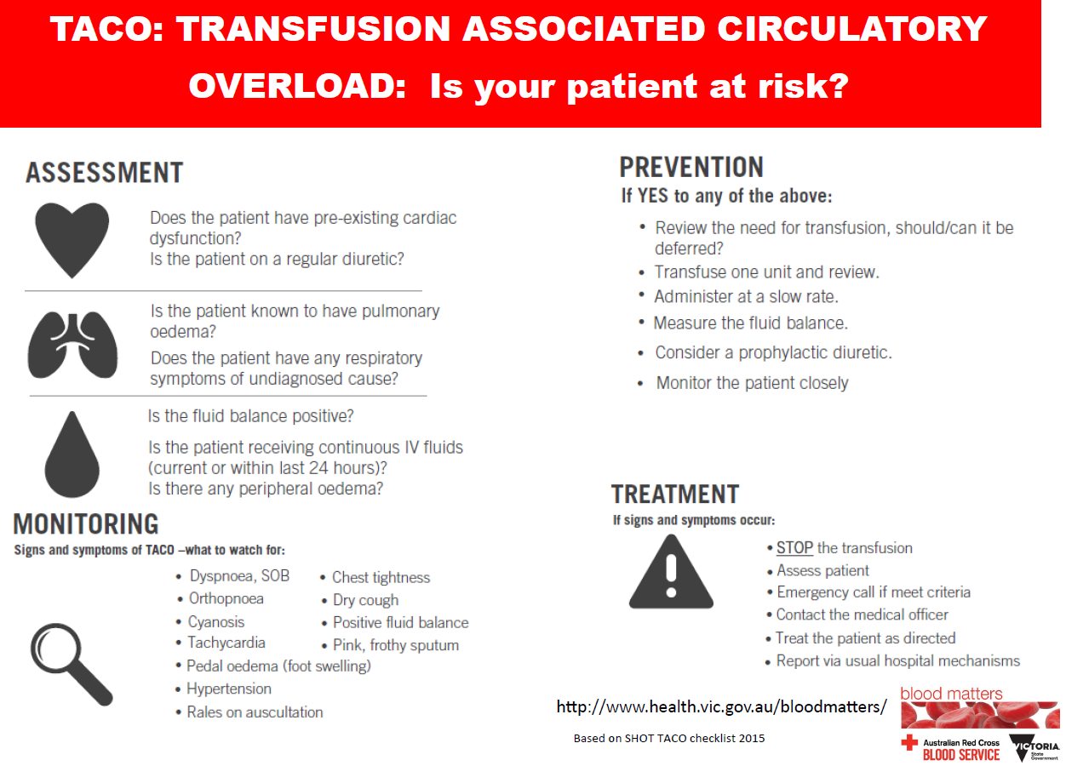

Blood Matters conducted a TACO awareness campaign in September 2017 where TACO checklist tags similar to the information provided above were attached to red cells with the assistance of Victorian pathology and health services. These tags provide information to clinical staff on patient assessment, monitoring and preventative measures. All the tools from the TACO awareness campaign are available on the Blood Matters website https://www2.health.vic.gov.au/hospitals-and-health-services/patient-care/speciality-diagnostics-therapeutics/blood-matters/serious-transfusion-incidents

