Making an Initial Authorisation Request

Submitting a New Initial Authorisation Request
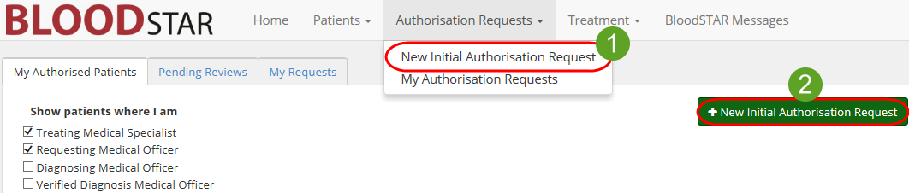
- There are two ways to start a New Initial Authorisation Request. The first is from your home page as a Medical Officer click the Authorisation Requests tab at the top of the page and click New Initial Authorisation Request. The second is to click the + New Initial Authorisation Request large green button on the homepage.
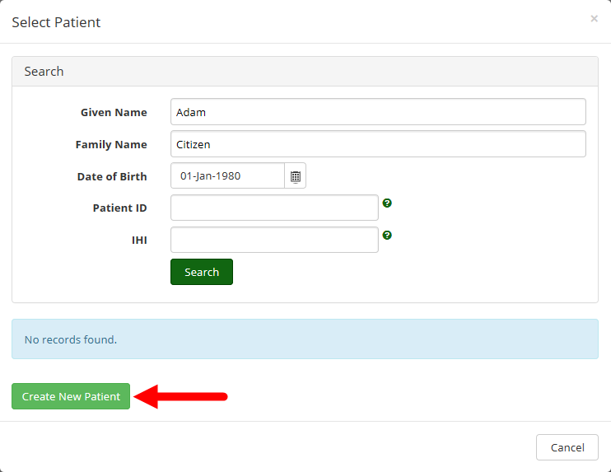
- A patient search window will appear, as pictured below. Enter the full name and date of birth of the patient, and click Search. If there is an exact match, the patient will appear for you to select and continue with a patient already in BloodSTAR; a partial match will not return results. If there is no match, select Create New Patient to progress with an authorisation request after entering the extra required details for that patient.
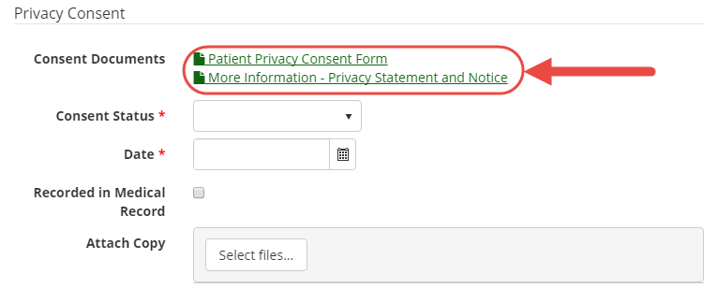
Patients must consent to having their details stored in BloodSTAR. Copies of the consent form and information for patients as to what details are recorded and why are available on the consent page in BloodSTAR. Enter in your patient’s consent status, select whether the consent granted was verbal or written, who granted the consent and the date it was obtained. You can nominate if the consent status is recorded in the medical record and also (optionally) upload a scanned copy of any consent you have received in writing.

- Once your patient’s basic details have been entered and consent obtained, you will be taken to Step 1 of the Authorisation Request. There are three functions you can perform on this page:
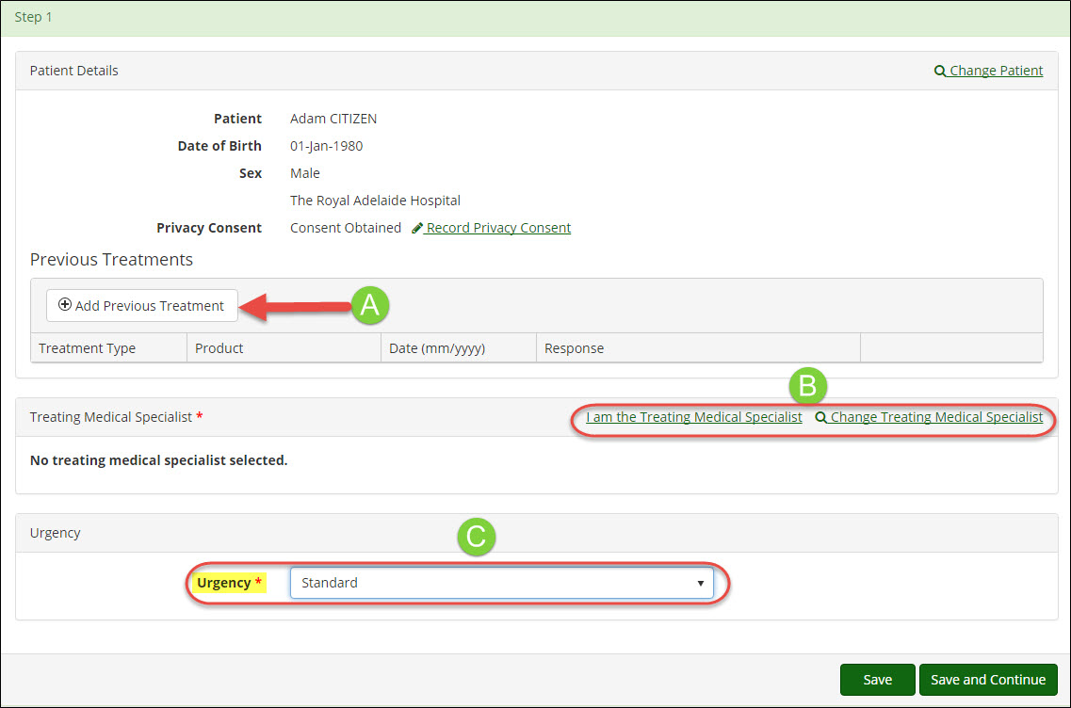
- If relevant, enter any previous treatments for the patient by clicking +Add Previous Treatment.
- Add the Treating Medical Specialist details to the form. If you are the Treating Medical Specialist click on I am the Treating Medical Specialist. If you are the Requesting Medical Officer select Change Treating Medical Specialist to nominate a prescribing specialist.
- Set the urgency of the authorisation. Please Note: Authorisations that have a status of Emergency must be accompanied by a call to your State/Territory authorisers.
Once all necessary details have been entered, click Save and Continue.

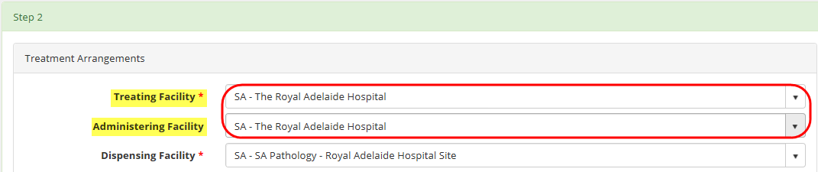
- In Step 2, your Treating and Administering Facility will be auto-populated as the facility where the nominated Treating Medical Specialist is registered. If your patient will physically receive treatment at another facility, select that site from the Administering Facility drop-down menu and, if not auto-populated, select a dispensing site.

The facility types are as follows:
- Treating Facility: the facility at which a specific patient's treatment will be managed (diagnosed, prescribed and reviewed). This may be the same location as the Ig infusion is administered.
- Administering Facility: the facility where the patient goes regularly to have their Ig infusions administered. This may be the same location that the patient sees their Treating Medical Specialist.
- Dispensing Facility: the facility from which it is anticipated that product will be normally dispensed for a specific authorised patient.

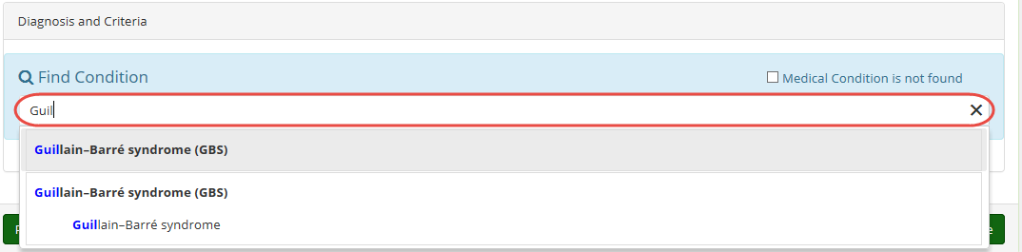
- Begin typing the diagnosis into the Medical Condition field. All the possible diagnosis options will populate to be selected. Once a medical condition has been selected, the page will continue to populate further required details under Qualifying Criteria and Supporting Evidence. To assist in the assessment of your authorisation request please ensure you enter as much information as you have available. When completed, click Save and Continue.
- In Step 3, enter the patient’s weight under the Dose heading. If you are calculating dosage by Ideal Body Weight, tick the corresponding box next to Patient Weight and a Height field will appear. This will then alter the weight value according to Ideal Weight values and change the requested dosage accordingly. Otherwise, just enter the patient’s weight.
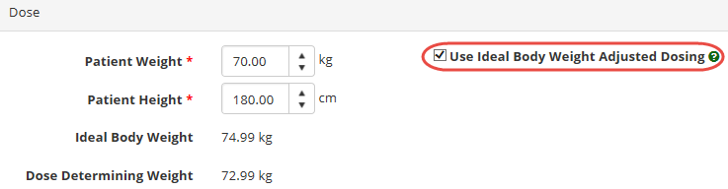
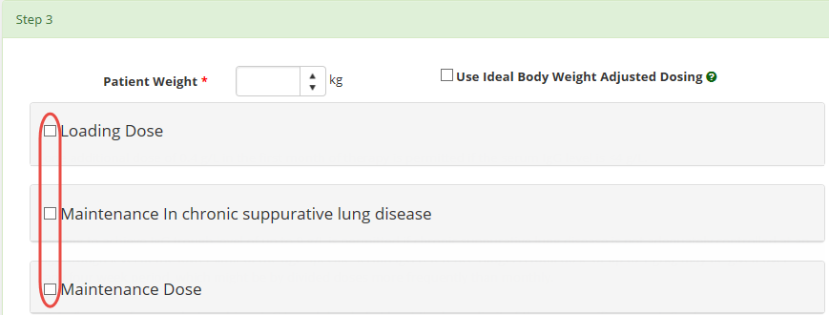
Select what kinds of doses are required, such as maintenance or loading dose, from the available options. The options available are determined by the diagnosis selected.

The product type and dosage per kilogram will be prepopulated and is determined by the entered diagnosis and your state. Enter the details of the treatment, including frequency, date required and any notes.
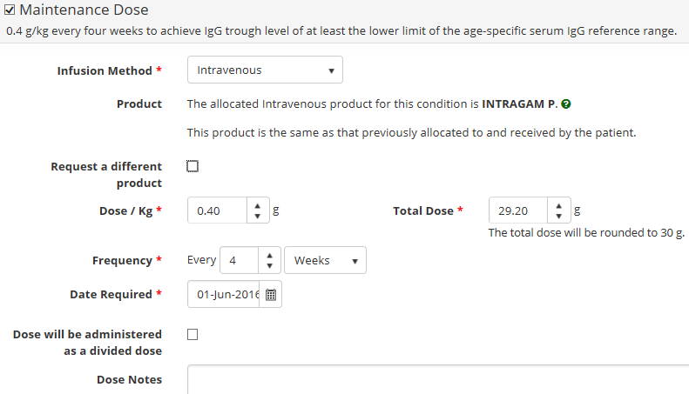
If you need to select a different product, tick the box marked Request a different product. A field will appear for you to select an alternate product and to provide a reason for the change. This reason is mandatory.
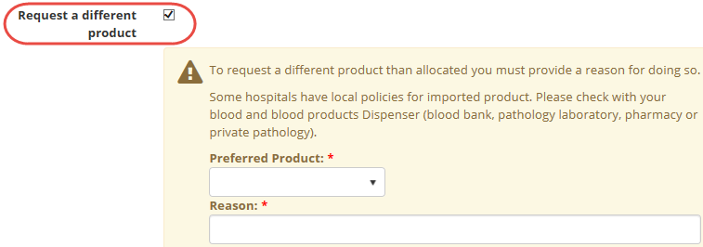
If the dose it to be administered as a divided dose, click on the Dose will be administered as a divided dose checkbox. The option to specify the number of divisions will appear as well as the option to specify your own divisions. If you do not select the Specify my own divisions option, BloodSTAR will automatically divide the dose as equally as is possible with the available vial sizes of the specified product. If you select the Specify my own divisions option, you will be able to customize the divisions of the total dose.
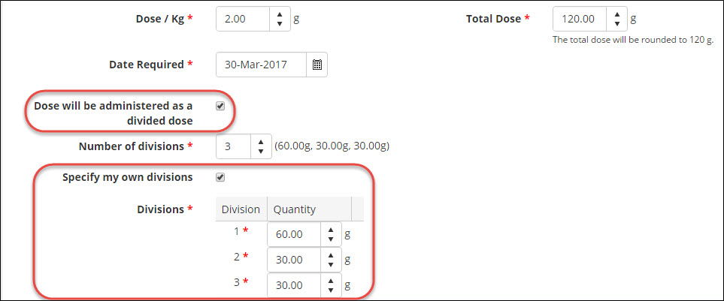

Treatment duration and amount per kilogram is calculated automatically off the weight entered for the patient. If you need to prescribe more than the recommended maximum of product per kilogram, enter this under Dose/Kg. If the Dose/Kg is higher than the recommended amount under the criteria you must enter a reason. When all details are completed, click Save and Continue.

- Confirm all details and check the box Accepting Terms and Conditions. Click Submit to complete the request.
