Dispensing from a Dispense Request
This tip sheet outlines how to dispense a dose of Immunoglobulin (Ig) in BloodNet directly from a dispense request. All Ig dispenses must be recorded in BloodNet.
- To dispense a directly from a dispense request click on the Dispense requests link.
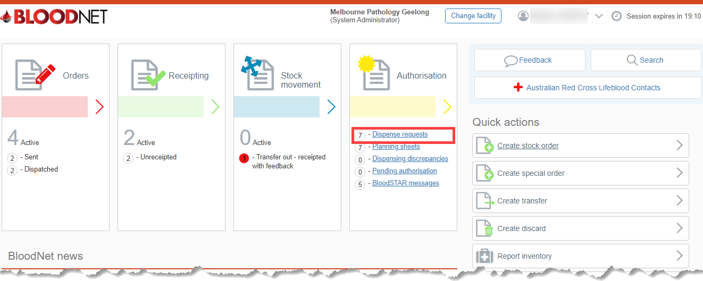
- A list of dispense requests will appear on the page. You also have the option to search for a request by filling in the search fields. Once you have located the request you can click directly on the Dispense link. Note: The option to view the request and delete the request is also available.
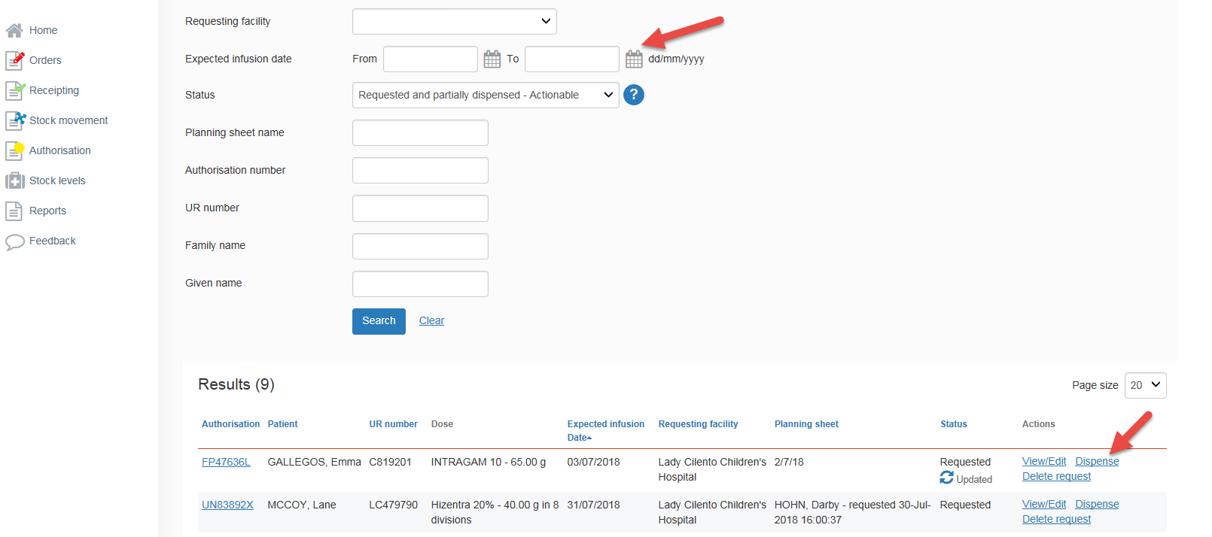

- Once you have clicked on the dispense link you can then scan in the product number and enter the expected transfusion date and save the dispense episode.
