Create a Return to Stock Episode
This tip sheet explains how to complete a Return to Stock episode for a patient on Immunoglobulin (Ig) product in BloodNet. A Return to Stock episode may be required for one of the following reasons: a product type is dispensed by mistake, too much product is dispensed by mistake, or a patient does not present or is too unwell for their scheduled infusion and their product is returned to the dispenser.
- Click on the ‘Authorisation’ tile on the BloodNet homepage.
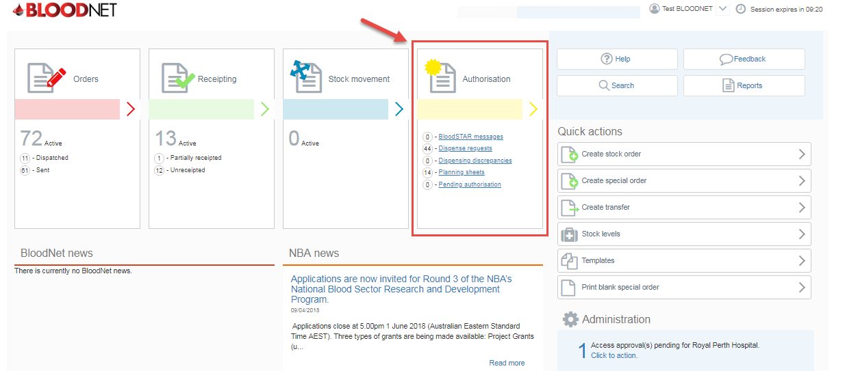
- Locate the patient from the Authorised patients list of the Authorisation dashboard or click on the All authorised patients link or Authorised patients button to view and search all patients at your facility. Once you’ve located your patient click on their Authorisation number link.
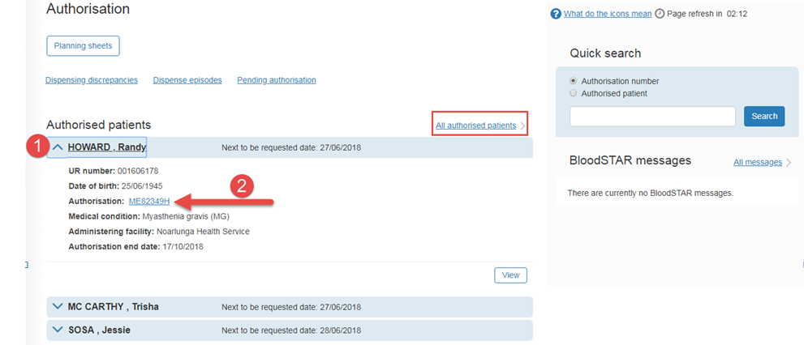

- On the View authorisation page scroll down the page to view the patient’s treatment plan. Once you have identified the dispense you want to remove/edit you will have to return to stock all the most recent dispenses until you get to the one you need to remove/edit. Once you have made the necessary changes you will then need to re-dispense all the relevant doses. Note; You will have to document the lot number for when you re-enter the product details.

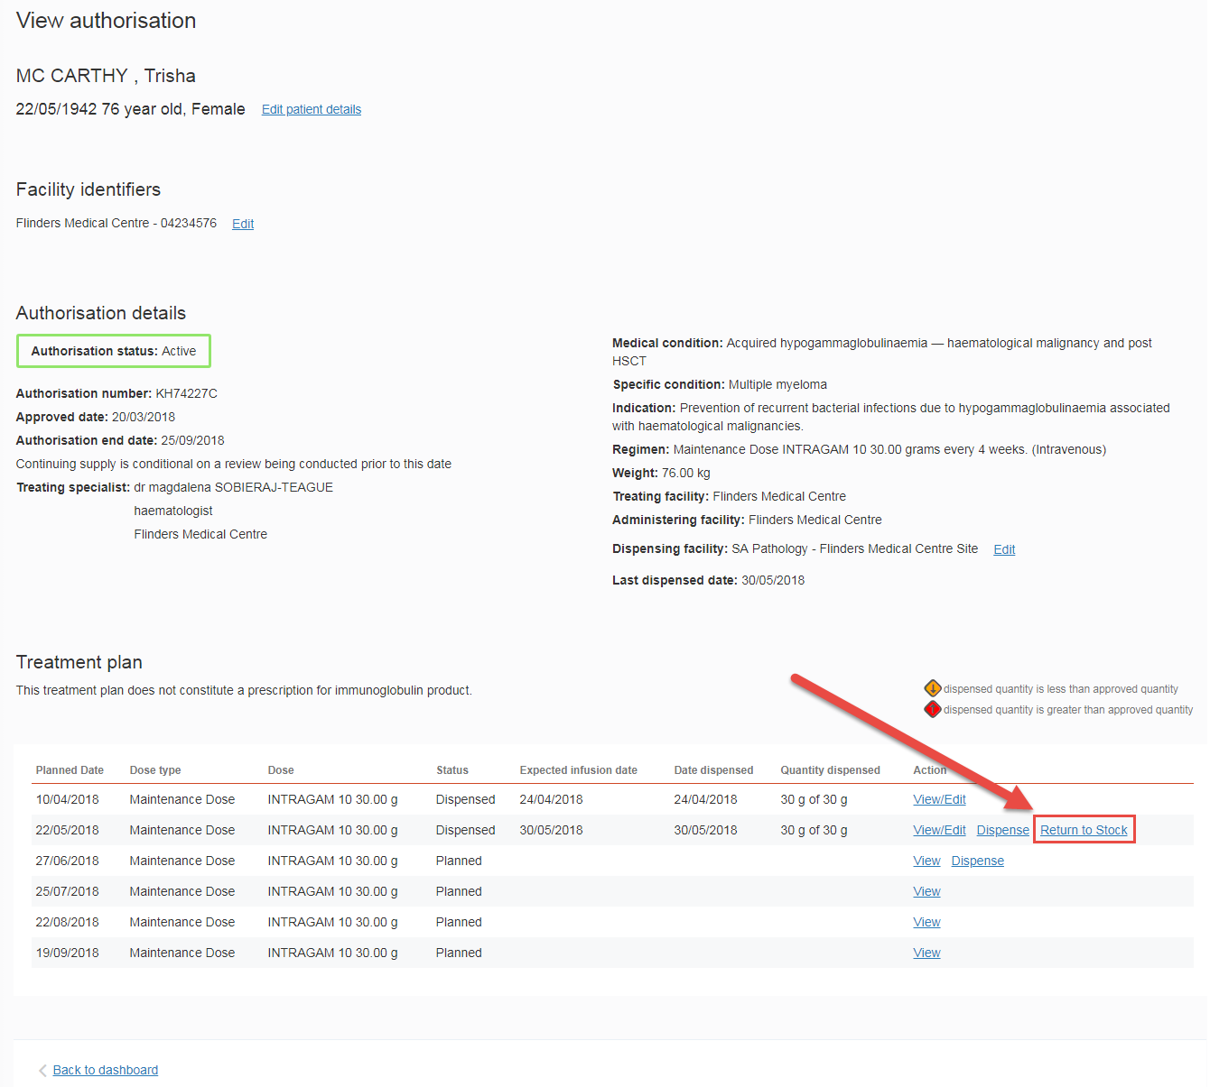

- On the Return to stock episode page you will see a list of the products that were issued in the dispense. Enter the date and time of the return to stock and click on the checkboxes on the lower right of your screen to select the products you want to return. Adjust the quantities of vials if required and then click the Save return to stock episode button.

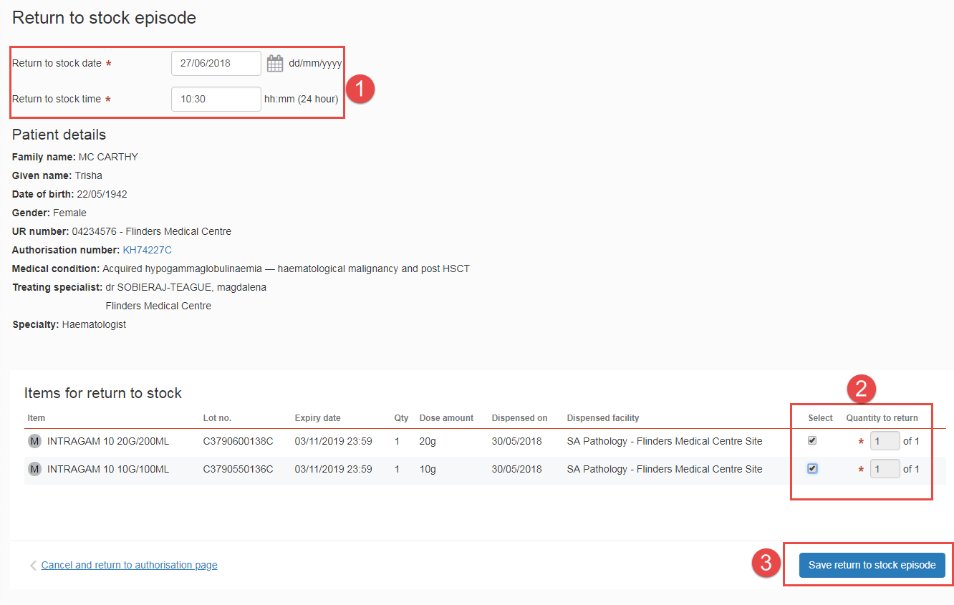

- You will now be back on the View authorisation page and will see a confirmation message at the top of the screen. You will also note that the treatment episode’s status has changed to either Partially Dispensed or Planned depending on the quantity returned.

