Creating a dispense from an authorisation record

This tip sheet outlines how to dispense a dose of Immunoglubuin (Ig) in BloodNet from a patient’s BloodSTAR
authorisation record. All Ig dispenses must be recorded in BloodNet.

Dispensing from an Authorisation treatment plan:

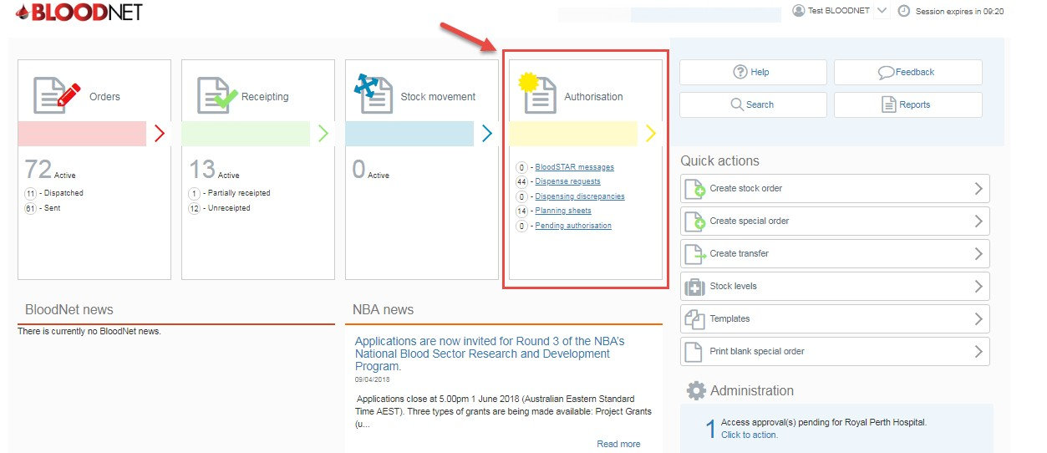1. Click on the ‘Authorisation’ tile on the BloodNet homepage.

2. Depending on how your Authorisation Dashboard is set up, you will see a list of your authorised patients and/or dispense requests and/or planning sheets. If present, review the patients listed under Authorised patients and
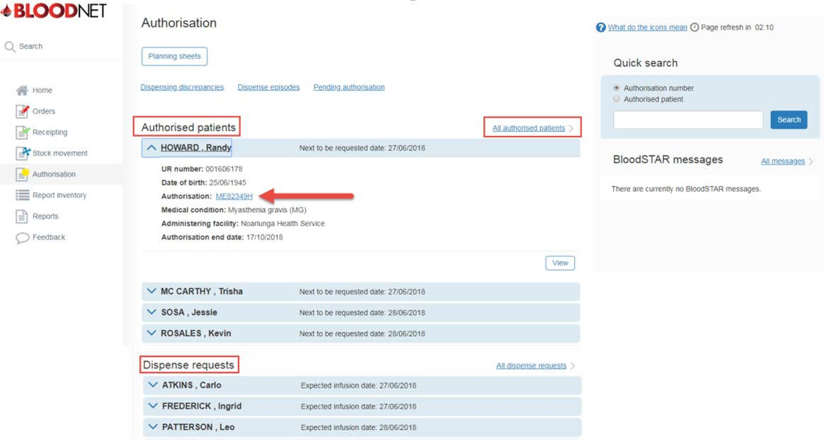if you can see the patient you’re looking for click the blue drop down arrow against the patient name and then click on the ‘Authorisation’ number link.

Support
Phone: 13 000 BLOOD (13 000 25663) Email: support@blood.gov.au
Fax: 02 6151 5210

authorised patients link which is located towards the top right of the authorised patients list. You will be taken
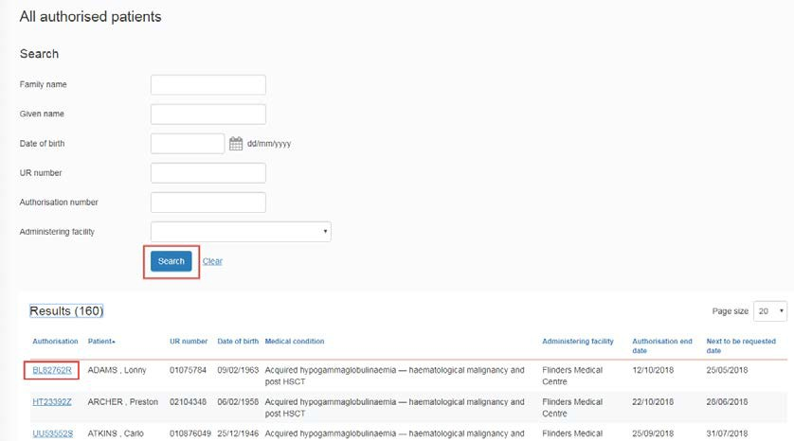to the All authorised patients screen where you can view and search all of the authorised patients at your facility. Once you’ve located the patient click on their Authorisation number link on the left of your screen.

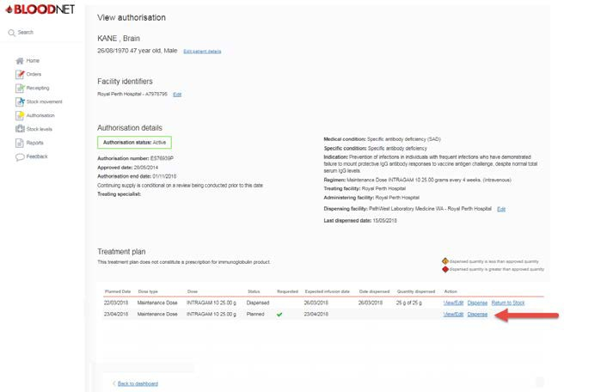4. You will now be on the ‘View authorisation‘ page which displays the patient’s authorisation details and their treatment plan. Scroll down the page to the treatment plan, locate the appropriate planned treatment and click on the ‘Dispense’ link on the right of your screen.

number/s and quantities of the required product/s in the blue box on the right of your screen. Also, if the
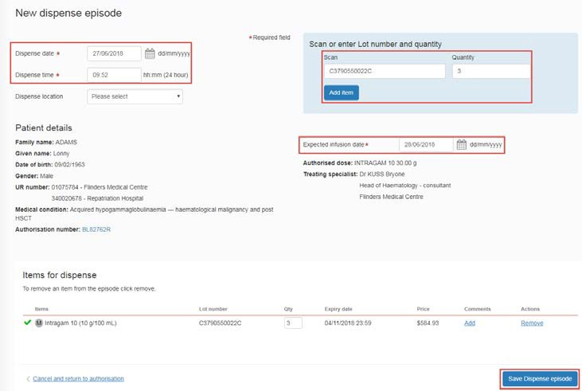Expected infusion date is incorrect, click on the calendar icon and update the date to the date the patient is receiving their infusion. The Expected infusion date is very important as the patient’s next treatment is calculated from this date. Finally, click the Save Dispense episode button at the bottom right of your screen to create the dispense episode.

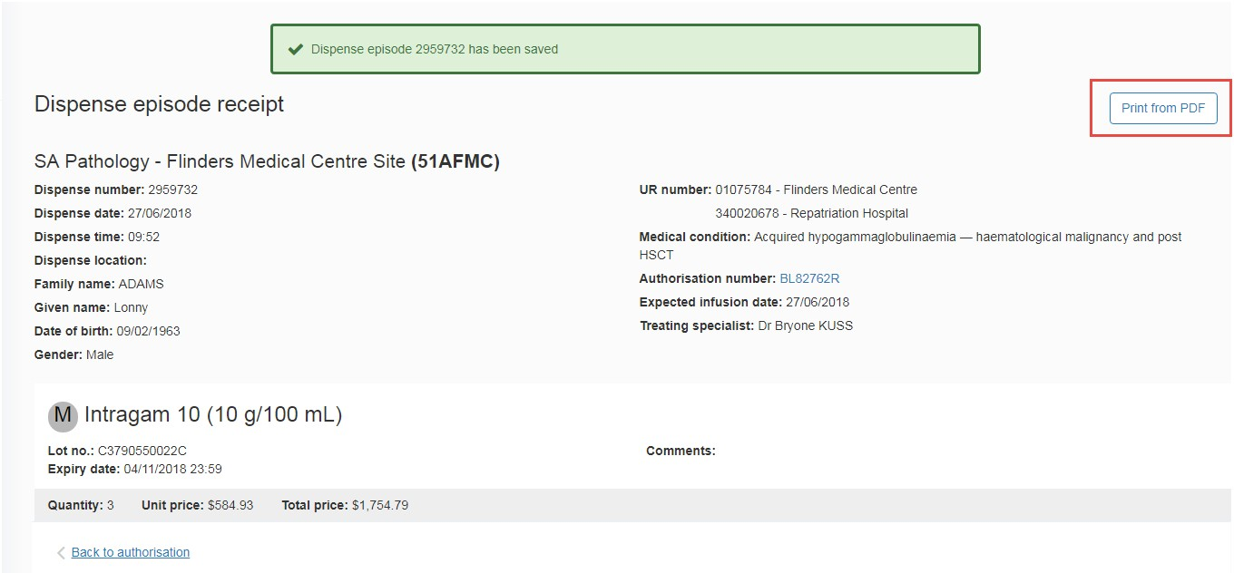6. You will now see a Dispense episode receipt which displays the details of the dispense. You can print the receipt by clicking on the Print from PDF button on the right of your screen. You will also see a confirmation message at the top of your screen to inform you that the dispense episode has been saved.

