Actioning Dispensing Discrepancies

Dispensing discrepancies are created when an Immunoglobulin product is dispensed for a patient outside of the authorisation constraints. If the dispense discrepancy reason is valid, you can resolve the discrepancy and provide justification. If the product was dispensed incorrectly it can be returned to stock via the patient’s authorisation. This tip sheet will explain how to action dispensing discrepancies in BloodNet.

- Click on ‘Dispense discrepancies’ hyperlink from your BloodNet home page.
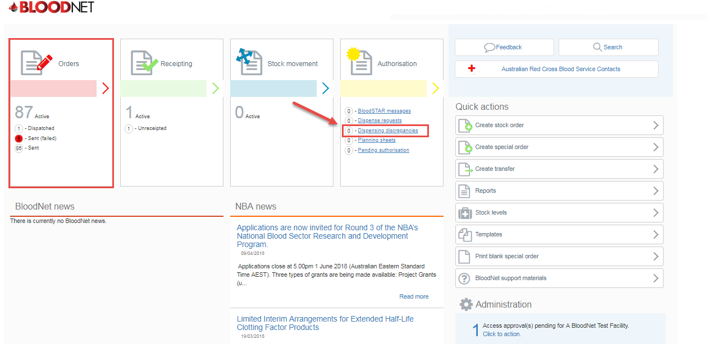

- The Dispensing discrepancies page will display a list of pending discrepancies. You have the option to view treatment episodes, view a patient’s authorisation or resolve a discrepancy by clicking on the appropriate hyperlinks.
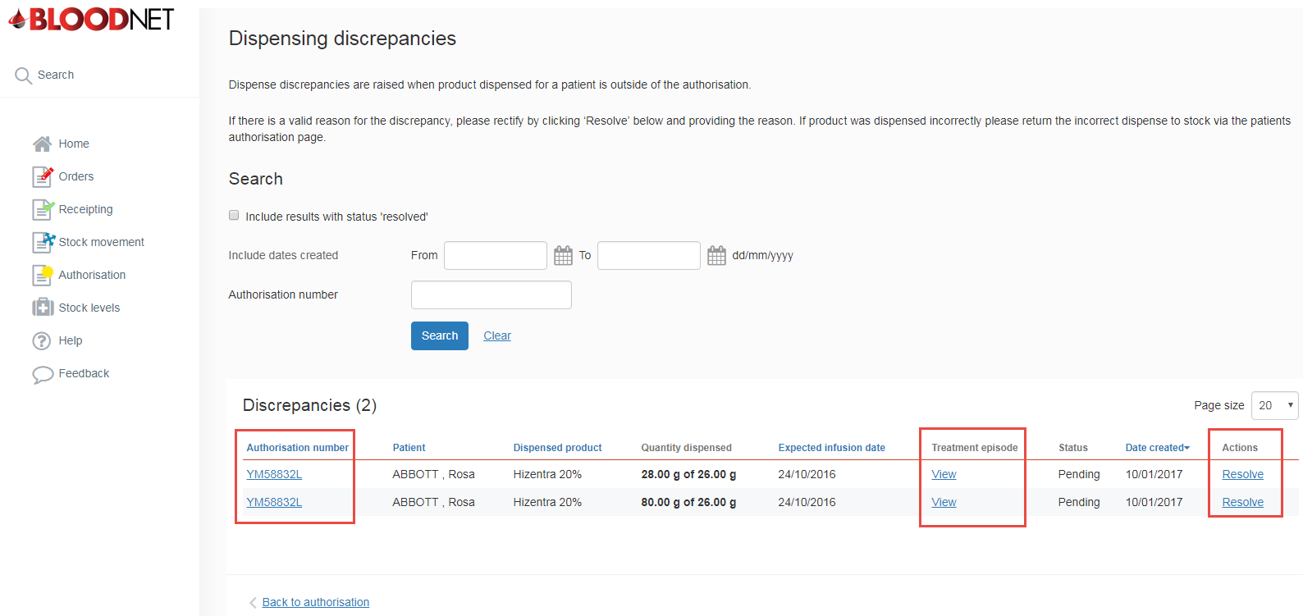

- To resolve a discrepancy click the ‘Resolve link’ on the right of your page. A window will open up on the screen that will give you the option to record a reason for the discrepancy. Enter the reasoning in the text box and click the ‘OK’ button.

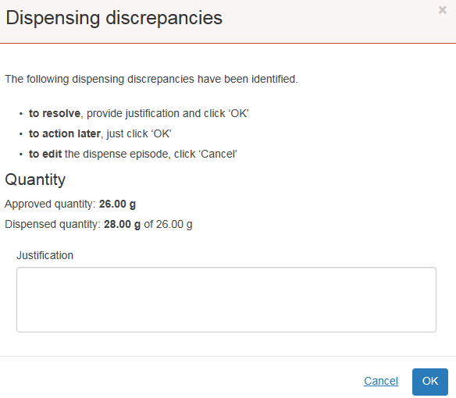

- If the discrepancy occurred due to an incorrect dispense then you can click on the authorisation number at the left of the screen to view the patient’s authorisation. This will allow you to view the patient’s treatment plan and complete a Return to Stock episode. This will remove the discrepancy.

